
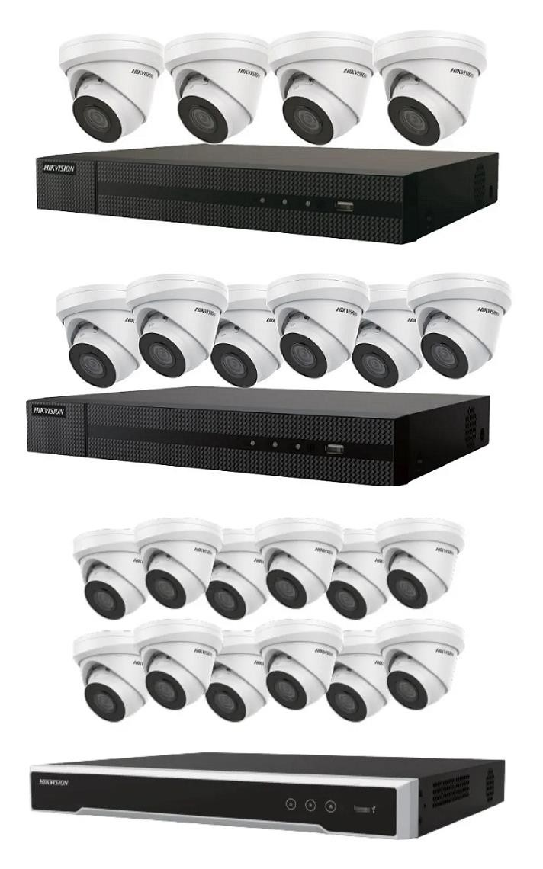

EKI-K41T44 EKI-K82T46 EKI-K164T412
4K Value Express Kits

Cameras
- 1/3" (4 MP) Progressive Scan CMOS
- 2560 x 1440 (4 MP) Resolution
- 2.8 mm Fixed Lens
- EXIR 2.0 with 100 ft (30 m) IR Range
- H.265+/H.265/H.264+/H.264/MJPEG
- IP67 Protection
- Durable Metal Housing
- 120 dB WDR for Clear Images

NVR
- Up to 8 MP Resolution Recording
- H.265+/H.265/H.264+/H.264/MPEG
- Plug-and-Play with 4, 8, or 16 PoE Cameras
- Up to 2 SATA Interfaces
Hikvision EKI-KxxxT4xx Series 4K Value Express Kits are cost-effective solutions for value-oriented users.
Each kit is supplied with four, six, or twelve network cameras with 4 MP image sensors and a 4-, 8-, or 16-channel NVR in the same box.
Kits are plug-n-play and can be set up quickly.

Available models:
EKI-K41T44: (1) ERI-K104-P4 NVR + 1TB HDD + (4) ECI-T24F2 Cameras
EKI-K82T46: (1) ERI-K108-P8 NVR + 2TB HDD + (6) ECI-T24F2 Cameras
EKI-K164T412: (1) ERI-K216-P16 NVR + 4TB HDD + (12) ECI-T24F2 Cameras



- Specification - for ECI-T24F2(C)

Camera
Image Sensor | 1/3" progressive scan CMOS
Max. Resolution | 2560 × 1440
Min. Illumination | Color: 0.01 Lux @ (F2.0, AGC ON), B/W: 0 Lux with IR
Shutter Time | 1/3 s to 1/100,000 s
Day ＆ Night | IR cut filter
Angle Adjustment | Pan: 0° to 360°, tilt: 0° to 75°, rotate: 0° to 360°
Lens
Lens Type | Fixed focal length, 2.8 and 4 mm optional
Focal Length ＆ FOV | 2.8 mm, horizontal FOV 98.0°, vertical FOV 53.1°, diagonal FOV 114.7°  4 mm, horizontal FOV 78.7°, vertical FOV 43.1°, diagonal FOV 92.3°
Lens Mount | M12
Iris Type | Fixed
Aperture | F2.0
Illuminator
Supplement Light Type | IR
Supplement Light Range | Up to 30 m
Smart Supplement Light | Yes
IR Wavelength | 850 nm
Video
Main Stream | 50 Hz: 20 fps (2560 × 1440), 25 fps (2304 × 1296, 1920 × 1080, 1280 × 720)  60 Hz: 20 fps (2560 × 1440), 30 fps (2304 × 1296, 1920 × 1080, 1280 × 720)
Sub-Stream | 50 Hz: 25 fps (640 × 480, 640 × 360)  60 Hz: 30 fps (640 × 480, 640 × 360)
Video Compression | Main stream: H.265/H.264/H.264+/H.265+  Sub-stream: H.265/H.264/MJPEG
Video Bit Rate | 32 Kbps to 8 Mbps
H.264 Type | Baseline Profile/Main Profile/High Profile
H.265 Type | Main Profile
Region of Interest (ROI) | 1 fixed region for main stream
Audio
Audio Compression | G.711ulaw/G.711alaw/G.722.1/G.726/MP2L2/PCM/AAC
Audio Bit Rate | 64 Kbps (G.711)/16 Kbps (G.722.1)/16 Kbps (G.726)/32 to 160 Kbps (MP2L2)/16 to 64  Kbps (AAC)
Audio Sampling Rate | 8 kHz/16 kHz
Environment Noise Filtering | Yes
Network
Protocols | TCP/IP, ICMP, HTTP, HTTPS, FTP, DHCP, DNS, DDNS, RTP, RTSP, RTCP, PPPoE, NTP,  UPnP™, SMTP, SNMP, IGMP, 802.1X, QoS, IPv6, Bonjour, IPv4, UDP, SSL/TLS
Simultaneous Live View | Up to 6 channels
API | Open Network Video Interface, ISAPI
User/Host | Up to 32 users. 3 levels: administrator, operator and user
Network Storage | NAS (NFS, SMB/CIFS), ANR

Client | iVMS-4200, Hik-Connect
Web Browser | Plug-in required live view: IE 10+  Plug-in free live view: Chrome 57.0+, Firefox 52.0+ Local service: Chrome 57.0+, Firefox 52.0+
Image
Image Settings | Saturation, brightness, contrast, sharpness, AGC, white balance adjustable by client  software or web browser
Day/Night Switch | Auto, Schedule, Day, Night
Wide Dynamic Range (WDR) | 120 dB
Image Enhancement | BLC, 3D DNR
Interface
Ethernet Interface | 1 RJ45 10 M/100 M self-adaptive Ethernet port
On-Board Storage | Built-in memory card slot, support microSD card, up to 256 GB
Built-in Microphone | Yes
Reset Key | Yes
Event
Basic Event | Motion detection, video tampering, exception
Linkage | Upload to FTP, notify surveillance center, send email,  upload to memory card, trigger recording, trigger capture
General
Power | 12 VDC ± 25%, 0.4 A, max. 5 W, Ø5.5 mm coaxial power plug  PoE: 802.3af, Class 3, 36 V to 57 V, 0.2 A to 0.15 A, max. 6.5 W
Material | Metal ＆ Plastic
Dimension | Ø127.3 mm × 95.9 mm (Ø 5.0" × 3.7")
Package Dimension | 150 mm × 150 mm × 141 mm (5.9" × 5.9" × 5.6")
Weight | Approx. 469 g (1.03 lb.)
With Package Weight | Approx. 705 g (1.55 lb.)
Storage Conditions | -30 °C to 60 °C (-22 °F to 140 °F). Humidity 95% or less (non-condensing)
Startup and Operating  Conditions | -30 °C to 60 °C (-22 °F to 140 °F). Humidity 95% or less (non-condensing)
General Function | Anti-flicker, heartbeat, mirror, password protection, privacy mask, watermark, IP  address filter
Approval
EMC | FCC SDoC (47 CFR Part 15, Subpart B);  IC VoC (ICES-003: Issue 6, 2016)
Protection | IP67 (IEC 60529-2013)

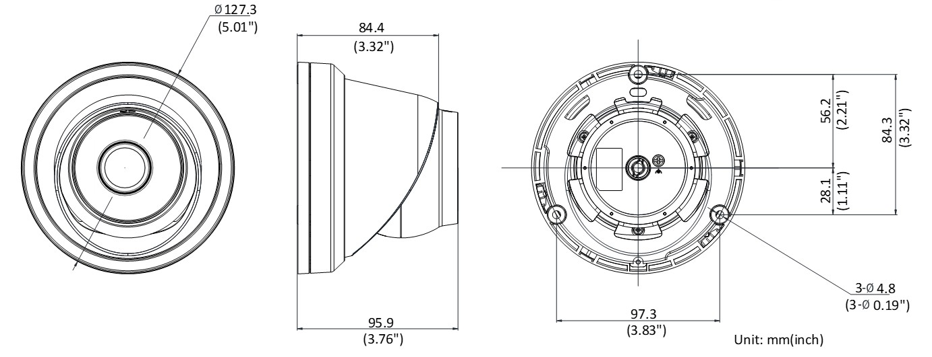
- Accessory
- Dimension
- Optional
CPM | CBM | CB130T | PM | PC130T
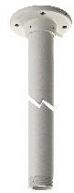 | 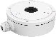 | 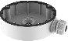 | 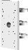 | 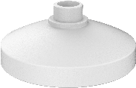
WML | ABM | CM
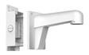 | 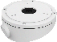 | 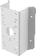


Specification

Model | ERI-K104-P4(C)
Video and Audio
IP video input | 4-ch
IP video input | Up to 8 MP resolution
Incoming bandwidth | 40 Mbps
Outgoing bandwidth | 80 Mbps
HDMI output | 1-ch, 4K (4096 x 2160)/30 Hz, 4K (3840 x 2160)/30 Hz, 2K (2560 x 1440)/60 Hz,  1920 x 1080/60 Hz, 1600 x 1200/60 Hz, 1280 x 1024/60 Hz, 1280 x 720/60 Hz
VGA output | 1-ch, 1920 × 1080/60 Hz, 1280 × 1024/60 Hz, 1280 × 720/60 Hz
Video output mode | HDMI/VGA simultaneous output
CVBS output | N/A
Audio output | 1-ch, RCA (Linear, 1 KΩ)
Two-way audio input | 1-ch, RCA (2.0 Vp-p, 1 KΩ, using the audio input)
Decoding
Decoding format | H.265+/H.265/H.264+/H.264
Recording resolution | 8 MP/6 MP/5 MP/4 MP/3 MP/1080p/UXGA/720p/VGA /4CIF/DCIF/2CIF/CIF/QCIF
Synchronous playback | 4-ch
Capability | 1-ch@8 MP (30 fps)/5-ch@1080p (30 fps)
Stream type | Video, Video & Audio
Audio compression | G.711ulaw/G.711alaw/G.722/G.726
Network
Remote connection | 16
Network protocol | TCP/IP, DHCP, IPv4, IPv6, DNS, DDNS, NTP, RTSP, SADP, SMTP, SNMP, NFS, iSCSI,  ISUP, UPnP™, HTTP, HTTPS
Network interface | 1, RJ-45 10/100 Mbps self-adaptive Ethernet interface
PoE
Interface | 4, RJ-45 10/100 Mbps self-adaptive Ethernet interface
Power | ≤ 50 W
Supported standard | IEEE 802.3 af/at
Auxiliary Interface
SATA | 1 SATA interface
Capacity | Up to 8 TB capacity for each disk
Alarm in/out¹ | N/A (4/1 is optional)
USB interface | Front panel: 1 × USB 2.0; Rear panel: 1 × USB 2.0
General
Power supply | 48 VDC, 1.35 A
Consumption  (without HDD and PoE off) | ≤ 10 W
Working temperature | -10 °C to 55 °C (14 °F to 131 °F)
Working humidity | 10% to 90%
Dimension (W × D × H) | 320 × 240 × 48 mm (12.4" × 9.4" × 1.9")
Weight (without HDD) | ≤ 1 kg (2.2 lb)

Specification

Model | ERI-K108-P8(C)
Video and Audio
IP video input | 8-ch
IP video input | Up to 8 MP resolution
Incoming bandwidth | 80 Mbps
Outgoing bandwidth | 80 Mbps
HDMI output | 1-ch, 4K (4096 x 2160)/30 Hz, 4K (3840 x 2160)/30 Hz, 2K (2560 x 1440)/60 Hz,  1920 x 1080/60 Hz, 1600 x 1200/60 Hz, 1280 x 1024/60 Hz, 1280 x 720/60 Hz
VGA output | 1-ch, 1920 × 1080/60 Hz, 1280 × 1024/60 Hz, 1280 × 720/60 Hz
Video output mode | HDMI/VGA simultaneous output
CVBS output | N/A
Audio output | 1-ch, RCA (Linear, 1 KΩ)
Two-way audio input | 1-ch, RCA (2.0 Vp-p, 1 KΩ, using the audio input)
Decoding
Decoding format | H.265+/H.265/H.264+/H.264
Recording resolution | 8 MP/6 MP/5 MP/4 MP/3 MP/1080p/UXGA/720p/VGA /4CIF/DCIF/2CIF/CIF/QCIF
Synchronous playback | 8-ch
Capability | 1-ch@8 MP (30 fps)/5-ch@1080p (30 fps)
Stream type | Video, Video & Audio
Audio compression | G.711ulaw/G.711alaw/G.722/G.726
Network
Remote connection | 64
Network protocol | TCP/IP, DHCP, IPv4, IPv6, DNS, DDNS, NTP, RTSP, SADP, SMTP, SNMP, NFS, iSCSI,  ISUP, UPnP™, HTTP, HTTPS
Network interface | 1, RJ-45 10/100 Mbps self-adaptive Ethernet interface
PoE
Interface | 8, RJ-45 10/100 Mbps self-adaptive Ethernet interface
Power | ≤ 75 W
Supported standard | IEEE 802.3 af/at
Auxiliary Interface
SATA | 1 SATA interface
Capacity | Up to 8 TB capacity for each disk
USB interface | Front panel: 1 × USB 2.0; Rear panel: 1 × USB 2.0
General
Power supply | 48 VDC, 1.88 A
Consumption  (without HDD and PoE off) | ≤ 10 W
Working temperature | -10 °C to 55 °C (14 °F to 131 °F)
Working humidity | 10% to 90%
Dimension (W × D × H) | 320 × 240 × 48 mm (12.4" × 9.4" × 1.9")
Weight (without HDD) | ≤ 1 kg (2.2 lb)

Specification

Model | ERI-K216-P16(C)
Video and Audio
IP video input | 16-ch
IP video input | Up to 8 MP resolution
Incoming bandwidth | 160 Mbps
Outgoing bandwidth | 80 Mbps
HDMI output | 1-ch, 4K (4096 x 2160)/30 Hz, 4K (3840 x 2160)/30 Hz, 2K (2560 x 1440)/60 Hz,  1920 x 1080/60 Hz, 1600 x 1200/60 Hz, 1280 x 1024/60 Hz, 1280 x 720/60 Hz
VGA output | 1-ch, 1920 × 1080/60 Hz, 1280 × 1024/60 Hz, 1280 × 720/60 Hz
Video output mode | HDMI/VGA simultaneous output
CVBS output | N/A
Audio output | 1-ch, RCA (Linear, 1 KΩ)
Two-way audio input | 1-ch, RCA (2.0 Vp-p, 1 KΩ, using the audio input)
Decoding
Decoding format | H.265+/H.265/H.264+/H.264
Recording resolution | 8 MP/6 MP/5 MP/4 MP/3 MP/1080p/UXGA/720p/VGA /4CIF/DCIF/2CIF/CIF/QCIF
Synchronous playback | 16-ch
Capability | 1-ch@8 MP (30 fps)/5-ch@1080p (30 fps)
Stream type | Video, Video & Audio
Audio compression | G.711ulaw/G.711alaw/G.722/G.726
Network
Remote connection | 64
Network protocol | TCP/IP, DHCP, IPv4, IPv6, DNS, DDNS, NTP, RTSP, SADP, SMTP, SNMP, NFS, iSCSI,  ISUP, UPnP™, HTTP, HTTPS
Network interface | 1, RJ-45 10/100/1000 Mbps self-adaptive Ethernet interface
PoE
Interface | 16, RJ-45 10/100 Mbps self-adaptive Ethernet interface
Power | ≤ 150 W
Supported standard | IEEE 802.3 af/at
Auxiliary Interface
SATA | 2 SATA interfaces
Capacity | Up to 8 TB capacity for each disk
USB interface | Front panel: 1 × USB 2.0; Rear panel: 1 × USB 2.0
General
Power supply | 100 to 240 VAC, 50 to 60 Hz
Consumption  (without HDD and PoE off) | ≤ 15 W
Working temperature | -10 °C to 55 °C (14 °F to 131 °F)
Working humidity | 10% to 90%
Dimension (W × D × H) | 385 × 315 × 52 mm (15.2"× 12.4" × 2.0")
Weight (without HDD) | ≤ 2.6 kg (5.7 lb)

