IDIS Solution Suite

Architectural and Engineering Specifications
Version 5.0.1
(Aug.29.2025)

Division 28 – Electric Safety and Security
Level 1 – 28.20.00 – Electronic Surveillance
Level 2 – 28.23.00 – Video Surveillance

Table of Contents
1 PART 1 - General 3
1.1 Summary 3
1.2 Administrative Requirement 3
1.3 Submittals 3
1.4 Quality Assurance 4
1.5 References 4
2 PART 2 – System Description 5
2.1 Manufacturer 5
2.2 General Description 5
2.3 System Requirements 7
2.4 System Diagram 9
3 PART 3 – VMS Features 11
3.1 Software Features 11
3.2 Product Features 25
3.2.1 Administration Service 25
3.2.2 Recording Service 25
3.2.3 Streaming Service 25
3.2.4 Monitoring Service 25
3.2.5 Video Analytics Service 25
3.2.6 Update Service 26
3.2.7 Backup Service 26
3.2.8 Recording Redundant Service 26
3.2.9 Video Wall Service 26
3.2.10 Federation Service 27
3.2.11 Failover Service 27
3.2.12 Mobile Service 27
3.2.13 Web Service 28
3.2.14 RTP Streaming Service 28
4 PART 4 - Execution 28
4.1 Preparation 28
4.2 Installation 28
4.3 System Software 29
Appendix. A. User Audit Log Table 30
Appendix. C. System log Table 33
Version History 44

PART 1 - General

Summary
- The VMS shall include but not limited to the following applications:
  - Server Software Applications
    - IDIS Solution Suite Expert: Standard package
    - IDIS Solution Suite Add-On: Add-on package
  - Client Software Applications
    - IDIS Solution Suite Client
    - IDIS Solution Suite Video Wall Agent (Client)
    - IDIS Mobile Plus : VMS Client mobile application(Android and IOS)
    - IDIS Player: the clip-copied image video player
- Related Requirements:
- Section 28.23.13 – Video Surveillance Control and Management Systems
- Section 28.23.16 – Video Surveillance Monitoring and Supervisory Interfaces
- Section 28.23.19 – Digital Video Recorder and Analog Recording Devices
- Section 28.23.23 – Video Surveillance Systems Infrastructure
- Section 28.23.26 – Video Surveillance Remote Positioning Equipment

Administrative Requirement
- Coordination
  - Coordinate with owner regarding camera network configuration and estimated bandwidth utilization prior to connection of cameras to owner’s network.

Submittals
Submittals described in this section shall be submitted by the Contractor with the original bid.
- Product Data
  - Submit manufacturer technical specifications, typical installation drawings, system overview drawings and sample images of items included in this section.
- Proposal Delta
  - It is the duty of the contractor to provide a working system. Any omissions or errors or differences between this document and the contractor’s submitted proposal shall be clearly outlined in a separate document labeled “[*COMPANY NAME] Proposal Deltas”.
- Qualification Statements
  - Manufacturer
    - Submit confirmation and details of manufacturer’s warranty, extended warranty, and replacement policies.
    - Submit proceeding [*3 years] financial statements for the equipment manufacturer.
    - Submit list of available manufacturer provided, fee based professional services available to the contractor or the owner including but not limited to: training, installation, commissioning, remote diagnostics and integration with 3rd party software and hardware systems.
  - Contractor
    - Submit confirmation that contractor is licensed to install video surveillance and security equipment as required by the authority having jurisdiction.
    - Submit history of contractor certification(s) for items in this section.
    - Submit references with contact information where contractor has installed items in this section.
    - Submit confirmation that installer [*Entity who will install this equipment or who will supervise installation of this equipment] has received manufacturer training and is certified by the manufacturer on this equipment and that the training the installer received is current.
    - Submit proceeding [*3 years] financial statements for the contractor.

Quality Assurance
- Manufacturer
  - Manufacturer shall have been in business for more than 20 years.
- Installer
  - Certification for authorized integrators/electronic technicians shall include at a minimum the installation and service of the equipment provided.

References
- Abbreviations and Acronyms
  - API – Application Programming Interface
  - DVR – Digital Video Recorder
  - GUI – Graphic User Interface
  - NVR – Network Video Recorder
  - IDIS Mobile Plus – VMS Client mobile application(Android and IOS)
  - VMS – Video Management System (or Software)

PART 2 – System Description

Manufacturer
- IDIS Co., Ltd.
IDIS Tower, 344 Pangyo-ro, Bundang-gu
Seongnam-si, Gyeonggi-do, 463-400, Korea
Tel: +82 31 723 5400
Fax: +82 31 723 5100

General Description
- The VMS specified is a highly scalable and fully integrated network video surveillance solution. The VMS can work together with network cameras, DirectIP NVRs, and DirectCX TVRs while providing superior image quality and extensive coverage. The VMS allows you to manage an unlimited number of devices and to customize your surveillance system cost effectively. So, the VMS is suitable for both large enterprise customers as well as smaller surveillance operations for home security and small business. The VMS provides a general purpose network video recording application that will satisfy a wide range of customer requirements without complicated licensing structures. The VMS is the solution for project-based surveillance rollouts as it optionally integrates and transforms to exact customer requirements.
- The VMS shall be available as a stand-alone software offering or pre-loaded on turn-key workstations and servers running Microsoft Windows with configurable storage.
- The VMS shall be available in a module based licensed software solution as follows:
  - Expert (Standard) Package
- Management Server:
    - Administration Service
    - Monitoring Service
    - Streaming Service
    - Recording Service
    - Video Analytics Service(IDLA Service)
    - Backup Service
    - Video Wall Service
    - Mobile Service
    - Web Service
    - RTP Streaming Service
    - Update Service
    - Client application
- Support Server:
- Streaming Service
- Recording Service
- Video Analytics Service(IDLA Service)
- Backup Service
- Video Wall Service
- Mobile Service
- RTP Streaming Service
- Update Service
- Administration Failover Service
- Recording Failover Service
- Redundant Recording Service
- Monitoring Failover Service
- Video Wall Failover Service
- Client application
- The Monitoring service and Web service can only be installed on the management server where the Administration Service is installed.

  - Federation Package
- Management Server
    - Federation Service
    - Monitoring Service
    - Backup Service
    - Video Wall Service
    - Web Service
    - Client application
- Support Server:
a. Backup Service
b. Video Wall Service
c. Federation Failover Service
d. Monitoring Failover Service
e. Video Wall Failover Service
f. Client application
- The Monitoring service and Web service can only be installed on the management server where the Federation Service is installed.

  - Video Wall Agent Package

- Licensing : USB dongle(Wibu-Key) or Software license.

System Requirements
- Server System.
The VMS shall operate on all of the following systems.

Recommended Spec.
OS :
- Microsoft Windows 10 (Home, Pro)
- Microsoft Windows 11 (Home, Pro)
- Microsoft Windows Server (2016/2019/2022)

CPU : Intel Core i5-3570 3.30GHz / Intel Xeon E3 or faster (4cores or more)
RAM : 4GB or more
VGA : NVIDIA GeForce GTX1060 or QuadroP2000 or higher (1920x1080x32bpp or higher), Multi-monitor
HDD : 2GB or more free space for each service (for example, 4GB or more free space when installing administration and monitoring services)
LAN : Gigabit Ethernet or faster

- Client System.
The VMS Client shall operate on all of the following systems.
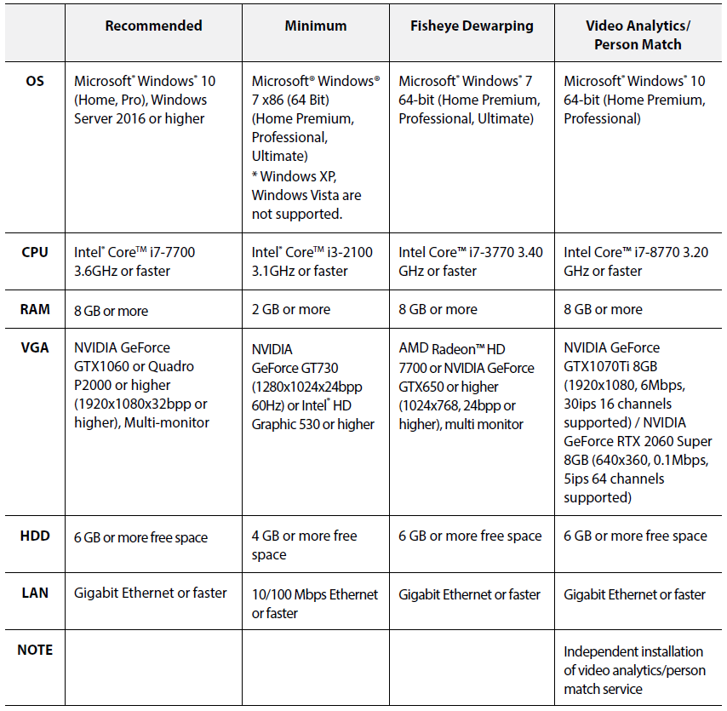

System Diagram
- Single-Server System
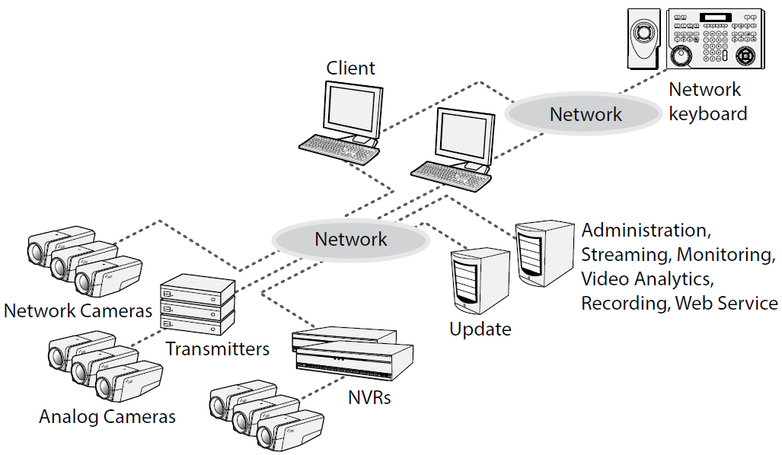

- Multi-Server System
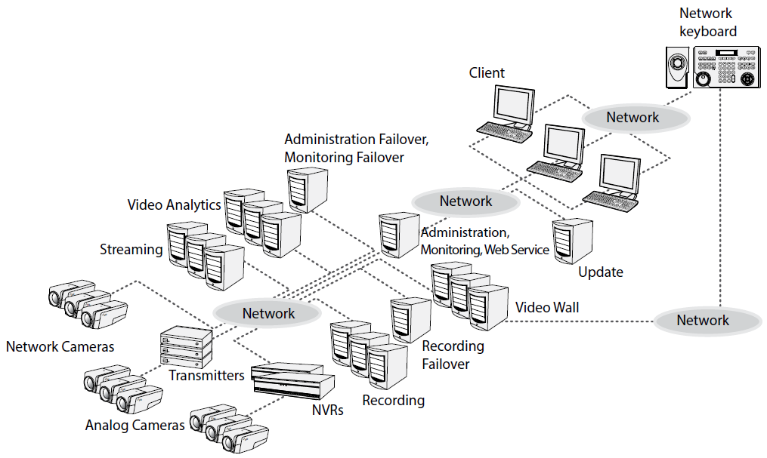

- Multi-Server Federation and Failover System
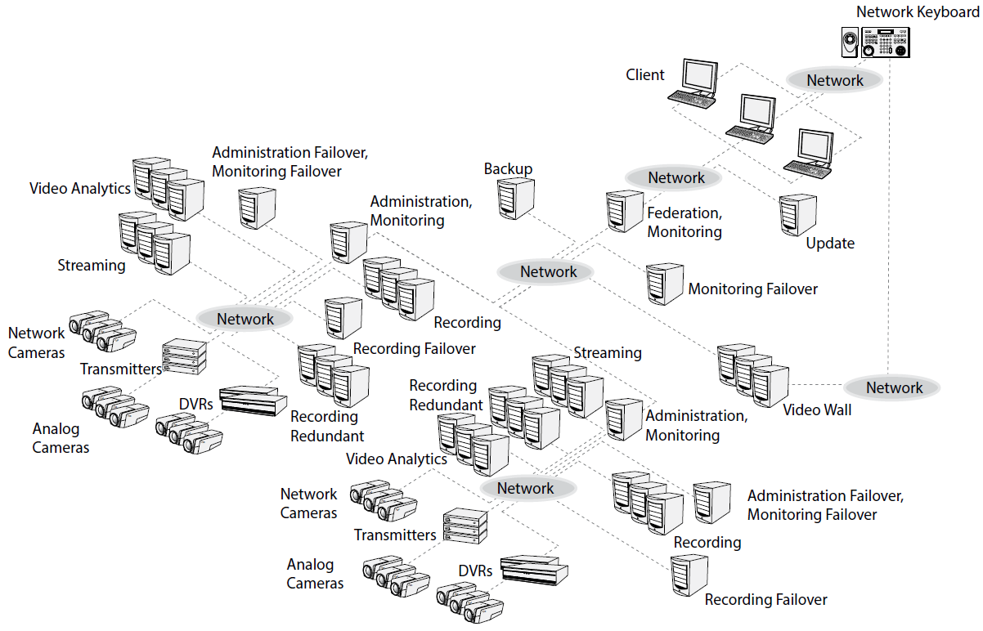

PART 3 – VMS Features

Software Features
- The VMS shall permit server and client software applications to be installed and run on both the same computer or on separate computers.
- The VMS shall support the remote monitoring of live image in multiple clients systems through a streaming service. The number of channels that can be streamed equals the number of channels that can be recorded unless streaming WIBU-Keys have been added.
- The VMS shall support the stable streaming by using the load balancing function in installation with more than one streaming server.
- The VMS shall remotely upgrade software and setup multiple systems which provide this feature.
- The VMS shall display the system log information of devices which use IDIS own protocol.
- The VMS shall monitor the map image on live monitoring screen.
- The VMS shall support the centralized system operation, management and event-handling.
- The VMS shall support the enhanced security using SSL function.
- The VMS shall support two-way audio communication and audio broadcasting.
- The VMS shall support the enhanced security by setting up different authorities for each user group.
- The VMS shall be controlled by IDIS network keyboard.
- The VMS shall support text-in and alarm function via TCP networking.
- The VMS shall support receiving digital input triggers and triggering digital outputs through an I/O board.
- The VMS will provide the mechanism by which individual alarm(s) from a 3rd party system (access control, etc.) can be pre-selected and configured to be monitored, and in turn trigger event driven video operations.
- The VMS shall support an intuitive GUI.
- The VMS shall support the following features for network cameras and network video transmitters:
  - Recording of video and playback of the recorded video
  - Multiple recording servers for advanced recording performance
  - Instant Recording/Panic Recording of monitored images
  - Audio recording
  - Stable recording using proprietary video database le system
- The VMS shall support the following features for DVRs:
  - Playback of video recorded in DVRs
  - Remote control of panic recording
- The VMS mobile client shall be free and supported by Android and Apple mobile devices.
- The VMS shall be available in the following languages:
  - English
  - French
  - German
  - Italian
  - Spanish
  - Croatian
  - Portuguese (Portugal)
  - Swedish
  - Finnish
  - Russian
  - Chinese (Simplified)
  - Chinese (Traditional)
  - Japanese
  - Korean
  - Turkish
  - Dutch
  - Czech
  - Polish
  - Hungarian
- The VMS shall support dynamic video stream management architecture which includes:
  - Support for industry standard compression formats including but not limited to:
    - MJPEG
    - MPEG-4
    - H.264
    - H.265
  - The client and server machine shall communicate resolution real estate such that the server machine acts as a video proxy and shall know the maximum monitor resolution supported by the client machine.
  - Support for reducing the required client bandwidth and processing power of a megapixel video stream by transmitting only the fraction of the video stream that is visible in the video display tile. (e.g. If a user is viewing a 2MP camera in a 352x240 resolution tile then a CIF representation of the 2MP image shall be transmitted).
  - Dynamic video stream management shall be supported for local users, remote users and mobile devices.
- The VMS shall support recording and management of video and audio sources including but not limited to:
  - IDIS IP Cameras and Encoders
  - IDIS Lite
  - Axis Cameras
    - Axis Encoders are not supported.
  - Panasonic BB Cameras
  - Panasonic WV (DG) Cameras
  - SISTORE Cameras
  - CostarHD Cameras
  - AV Costar Cameras
  - ONVIF Conformance Cameras
  - RTSP / RTP Video Streams
- The VMS shall support recording and monitoring video and audio streams from sources with bandwidth up to 200Mbytes/sec, frame rate up to 30 fps, and video resolution up to 12MP. This specification depends on the performance of server or workstation including HDD performance.
- The VMS shall support the decompression of H.264 and H.265 video through the quick sync video technology of Intel based client graphics card/graphical processing unit (GPU) instead of using the client processing power.
- The VMS shall require no proprietary recording hardware, no hardware multiplexer or time-division technology for video and audio recording or monitoring.
- The VMS shall support the storage capacity with up to 50TB per partition and shall allow for upgrades of recording capacity without additional licensing.
The VMS shall support max 74 partitions per one Recording Service.(Logical Drive Partition 24ea + Physical Drive Partition 50ea)
- The VMS shall secure video and audio data by securely transmitting all command and control data via TCP/IP using cryptographic keys based on SSL to prevent eavesdropping or tampering.
- The VMS shall support software level integration via an API. The API integration shall include but not limited to:
  - Bi-directional alarm event processing for monitoring and acknowledgement
  - Receiving digital input events
  - Receiving intrusion zone events
  - Transmitting live and recorded video
- The VMS shall support integration with the following systems:
  - Johnson Control - CCure 9000
  - Lenel - OnGuard
  - Gallagher - Command Centre
  - Inner range - Integriti
  - SensoGuard – CCS(Command and Control Software)
  - VCA Technology Ltd. – VCA Bridge
  - DAVANTIS Technologies – Daview S, Dabiew LR
- The VMS client shall provide alarm management operations through the use of the client graphical user interface. Including but not limited to:
  - Occurrences for “Alarm” and “Reset” conditions for each of the pre-selected access system alarms will be processed and managed from the VMS system’s Live View workspace.
    - In a section reserved for displaying alarm notifications or from an alarm viewer.
    - Alarms can also be acknowledged from the camera display tile.
  - Once an initiated alarm occurrence is acknowledged from the VMS system, it should be automatically acknowledged and processed in the access system alarm monitor queue without further operator intervention.
- The VMS shall have an easy process for upgrading versions:
  - Are capable of being upgraded from one version to another without having to uninstall the previous version.
- The VMS shall run as a service configured to automatically start when the server or workstation is powered on, and automatically recover from failure or attempted tampering.
- The VMS shall allow users to monitor and administer the system from:
  - A single client application for monitoring live and recorded video and audio.
  - A single window for administrating all system connections.
  - Any client located on the network.
- The VMS shall provide an automatic discovery solution that will easily find devices and systems by:
  - Automatically discovering server instances that run on computers connected to the same network as the client.
  - A search functionality to discover server instances running on computers connected on a different network segment than the client by using IP addresses or hostnames.
  - Automatically discovering video and audio sources that are connected to the same network as the server.
  - A search functionality to discover video and audio sources that are connected on a different network segment than the server.
- The VMS shall allow manually discovered server instances, video and audio sources to be visible to all users of a single client workstation.
  - Network settings for all server instances will be identical for all users of a single client workstation.
- The VMS shall provide multiple methods for providing fault tolerant solutions to maintain high availability recording in mission critical installations including:
  - The ability to maintain a centralized system administration so that the same operation and system configuration settings are shared between all servers in a site. This allows the same user login details and other configurations to be used across a site, and ensure that the settings remain active even if a server fails.
  - The ability to connect a video or audio source to multiple VMSs to achieve redundant recording.
  - The ability to create a failover connection for a video or audio source. If the VMS that the video or audio source is connected to goes offline then the failover VMS will take over the connection.
- The VMS shall detect if the video or audio signal is lost and alert the system administrator.
- The VMS shall provide the capability to rename all video and audio sources and NVRs.
- The VMS shall record video and audio streams based on a recording schedule that can be defined individually for each video source. The schedule shall include but not limited to the following parameters:
  - Recording Mode
    - Continuous (TimeLapse)
    - Event
Event Condition
a) Video Analytics
- Motion Detection
- Object Detection
- Face Detection
- Intrusion
- Line Crossing
- TripZone
- Loitering
- Crowd Detection
- Abandoned Object Detection
- Removed Object Detection
- Fall Detection
- Violence Detection
- Auto Tracking
b) Signal/Network
- Video Loss
- Video Blind
- Tampering
- Tampering Switch
- PSE Loss
c) Audio
- Audio Detection
d) Alarm I/O
- Alarm-In
- User Alarm-In
- PIR Detection
- Door Opened
- Network Alarm
- Text-In
e) Environmental
- Temperature Alarm On
- Heat
- Thermal High
- Thermal Low
- Thermal Delta
f) Intercom
- Client Call Requested
- Intercom Call Requested
- Missed Call Requested
g) Vehicle/ANPR
- ANPR Detection
- ANPR Denylist Detection
- ANPR Allowlist Detection
h) Special/Emergency
- Emergency
  - Time and Date Settings
    - One day
    - Daily
    - Weekly
    - Monthly
    - Yearly
- The VMS shall provide the ability to manually trigger recording.
- The VMS shall provide a pre-event and post-event recording option.
- The VMS shall provide a continuous recording option in the absence of events.
- The VMS shall perform motion detection on each individual video source with adjustable sensitivity, threshold and detection zones.
- The VMS shall perform analytics event detection on each individual video stream sourced from a device possessing adaptive video analytics capabilities.
  - The VMS shall allow users to connect individual video sources to analytics appliance channels.
  - The VMS shall allow users to configure events based on classified object motion detection.
  - The VMS shall allow configured analytics events to be used as alarm and rule triggers.
- The VMS shall provide the ability to set a maximum recorded video retention time for each video source.
- The VMS shall perform dynamic bandwidth management to ensure the total bandwidth does not overload the system.
- The VMS shall authenticate users before granting access to the system. Access rights for each user can be defined individually for each user, and shall include but not be limited to:
  - Live monitoring
    - Use PTZ setup and controls
    - Use audio in/out controls
    - Use instant recording
    - Use image processing
    - Export live images
    - Trigger manual recording (panic recording)
    - Use web browser in live tab
  - Search and Play
    - Save AVI or ClipCopy images
    - Export images
    - Use image processing
    - Search the recorded data by motion, object or other events
    - Play manually recorded data (panic record play)
  - Device Health Monitoring
  - Use alarm in/out controls
  - Search and export log data
  - Search and export event history
  - Show device and device group
  - Create user layout
  - Show POS transaction (text-in) messages
- The VMS shall provide the ability to rank access rights based on a user’s position within a corporate hierarchy.
  - Ranked users may only administer changes to users and groups that are subordinate in rank.
  - The corporate hierarchy can be used to enforce the authority of a parent site over the user and group settings of one or more child sites.
- The VMS shall allow the creation of site families.
  - A child site can be connected to an appropriately licensed parent site.
  - The parent site will have control over the group and user privileges and information of a child site.
- The VMS shall support multiple credentials to gain access to the system including, but not limited to:
  - The ability to import members of Active Directory groups as users in the VMS.
    - Changes made to members in the Active Directory are automatically synced with the VMS.
    - Users imported from the Active Directory can be added directly to existing permission groups.
  - Using Windows credentials to authenticate users.
  - Accept user credentials entered into the VMS user database.
- The VMS shall provide the ability to schedule backups of recorded video with associated events to a local folder or mapped network drive.
- The VMS shall provide the ability to create and schedule alarms and corresponding actions including:
  - Provide the ability to email users and system administrators when an event or system health error occurs.
  - Provide the ability to schedule when email notifications are sent.
  - Provide the ability to include camera images in email notifications.
- The VMS shall maintain a system event log. Including but not limited to the events shown in APPENDIX.A. System Log Table.
- The VMS shall have the capability to schedule and execute any of the following actions in response to any of the events listed above:
  - User Notification Actions
    - Display on-screen message
    - Send an email
    - Play a sound
  - Monitoring Actions
    - Start live streaming video
    - Create Bookmark
    - Start live streaming on a virtual matrix monitor
    - Open a map on a virtual matrix monitor
  - Device Actions
    - Reboot camera
    - Trigger digital output
  - PTZ Actions
    - Go to Preset
    - Run a Pattern
  - Alarm actions
    - Trigger an alarm
    - Acknowledge an alarm
- The VMS shall provide the ability to escalate alarms from one user or group to another if the alarm is unacknowledged for a preset duration.
- The VMS shall provide a maintenance log and audit trail of all system errors and events.
- The VMS shall support the operation of a Point of Sale system that include:
  - The ability to receive transaction information from point-of-sale sources.
  - Support multiple encoding formats from point-of-sale sources.
  - The ability to monitor live and recorded transactions from point-of-sale sources with linked video.
  - The ability to generate events based on point-of-sale transaction exceptions.
- The VMS shall support the operation of a License Plate Recognition system that include:
  - The ability to define a region of an image where license plate detection is performed. Detected license plates shall be stored with the video data.
  - The ability to create a Watch List that is used to create events when specific license plates are detected in the images being analyzed.
- The VMS shall provide the ability to enable and configure PTZ control on the RS-485 interface of a video source.
- The VMS shall support PTZ protocols and models. Including but are not limited to the following:
  - IP Cameras
    - IDIS IP Cameras and Encoders
    - Axis Cameras
    - Panasonic BB Cameras
    - Panasonic WV (DG) Cameras
    - SISTORE Cameras
    - CostarHD Cameras
    - AV Costar Cameras
    - ONVIF Conformance Cameras
    - RTSP/RTP
  - The VMS shall support more PTZ models and protocols as shown in [APPENDIX. B. ANALOG PTZ MODEL & PROTOCOL SUPPORTED BY IDIS ENCODERs, DVRs or NVRs] using IDIS Encoder, DVR or NVR additionally.
- The VMS shall provide the ability to change the network settings for a video and audio source including:
  - A change in image quality and image rate parameters for a single video source shall not affect the settings of other video sources.
  - The ability to enable a secondary stream for live viewing.
  - The ability to change the exposure, iris, IR filter, backlight compensation, gain, sharpening, noise filtering, saturation, focus, and white balance settings for a video source.
  - The ability to change the image dimensions for a video source.
  - The ability to rotate the image 90°, 180° or 270° for a video source dependent on camera.
  - The ability to add privacy zones to a video source to block unwanted areas in the image field of view.
  - The ability to set a maximum recording duration for manually triggered recording for a video source.
  - The ability to change the input, output, gain and volume for an audio source.
- The VMS shall support the use of uni-directional and bi-directional audio.
  - The VMS shall support full-duplex two-way audio communication.
  - The VMS shall provide the ability to link any audio source to any video source.
    - Able to link multiple audio sources to a single video source. But, multiple audio signal output is not supported.
    - Able to link an audio source to many video sources.
  - The VMS shall provide the ability to synchronize audio and video on playback regardless of video, audio, network, or storage parameters
- The VMS shall provide the ability to manage operator access to the VMS and assets, including:
  - Ability to automatically log in to a VMS.
  - Ability to override user access to a VMS if there are insufficient licenses.
  - Ability to automatically log out of a VMS when the application is left idle.
  - Ability to save and restore the window layout.
  - Ability to control the system using a PC keyboard, mouse or joystick.
  - Ability to import and export system settings such as maps, views, web pages, users and groups.
- The VMS shall support live or recorded video monitoring of 1 to 64 video streams simultaneously on a single monitor with the following standard layouts:
  - Normal Screen
    - Full Screen, 2x2, 3x3, 4x4, 5x5, 6x6, 8x8, 1+5, 1+7, 1+11, 1+12, 1+27, 1+32, 2+8, 2+18, 3+4, 4+28, 12+16
    - Corridor Format: 1x2, 1x3
  - Wide Screen
    - 3x2, 4x3, 5x4, 6x5, 7x6, 8x7, 1+2, 1+3, 1+4, 1+5, 1+6, 1+8, 1+10, 2+1, 2+4, 2+12, 4+12, 12+24
    - Panoramic Format : 1x1, 2x1, 8x1
- The VMS shall support live or recorded video monitoring in a customizable video display beyond the standard layouts.
- The VMS shall be able to simultaneously display video streams from maximum 64 client sites.
- The VMS shall support the ability to bias the displayed video to a lower frame rate or to a lower image resolution if the client network bandwidth or processing power is insufficient for displaying the video at full frame rate and image resolution.
- The VMS shall support the ability to display image overlays. Including but not limited to the following:
  - Live
    - Camera Title, Status Icon, PTZ, Timestamp (Date &Time), Event Alert, Motion Block, Site Name, Face Detection, Text-In messages.
  - Playback
    - Camera Title, Recorded Title, Status Icon, ePTZ, Timestamp (Date &Time), Site Name, Face Detection, Text-In messages.
- The Video Analytics Activity overlay shall provide a color-coded bounding box around moving objects categorized as humans or vehicles.
- The VMS client software shall:
  - Maximum four monitors used for monitoring video and audio streams connected to a single workstation.
  - Support monitoring live and recorded video and audio streams simultaneously on the same monitor.
  - Support viewing the same live or recorded video stream at different zoom levels and areas of interest.
  - Support the ability to switch from live to recorded video on demand for an instant replay of recently recorded video.
  - Support the ability to share the application window display in a joint session with other users for collaborative investigations.
  - Support the creation various layouts of video streams.
  - Support the ability to toggle between tiled and full-screen view.
  - Support the ability to save views.
  - Support the ability to cycle through views (guard tour) based on a specified interval.
  - Display all video sources connected to the system.
  - Support the ability to drag and drop sources from a system tree. Sources include but are not limited to:
    - A video/audio source for live and recorded display.
    - A predefined layout view of video/audio sources.
    - Third party or integrated devices
    - Web pages
    - Graphical maps
- The VMS shall support the ability to configure how the system tree is displayed.
  - The system tree of video sources, maps, saved views and web pages can be organized into virtual folders that are represented as branches within the Site.
  - Users can be granted access to individual items or entire folders within the tree.
  - New items added to a folder automatically inherit the permissions of that folder.
- Alarm and Digital Output Management:
  - The VMS shall support monitoring alarms.
  - The VMS shall support the ability to designate one or more regions/tiles in a window for displaying video directly linked to triggered alarms and rules.
  - The VMS shall support the ability to acknowledge alarms from the designated video display area.
  - The VMS shall support the ability to manually trigger digital output:
    - Through the use of a pre-configured software “button”.
    - Through the use of a hard-wired dry alarm contact connected to a supported input/output device.
  - The VMS shall support the ability to assign alarms to users.
  - The VMS shall support the ability to acknowledge alarms.
  - The VMS shall support the ability to bookmark alarms.
- The VMS shall support creating bookmarks for recorded video and audio. Bookmarks can be:
  - Viewed from multiple sources
  - Displayed on the timeline during playback
  - Used as a search criteria for recorded video and audio. Search criteria can include but are not limited to:
    - Name
    - Description
    - Bookmark Creator
- The VMS shall support the ability to create a map that represents the physical location of cameras and other devices throughout the surveillance system.
  - Maps shall be created from images stored in standard image formats. Including but not limited to the following:
    - JPEG
    - BMP
    - PNG
    - GIF
  - Maps shall have the ability to contain links so as to create a hierarchy of interlinked maps.
  - Maps shall support the ability to drag and drop a video source from the map into a window for live or recorded video and audio monitoring.
  - Cameras in a map are highlighted when an alarm linked to the camera is triggered.
- The VMS shall support physical and digital zooming and panning on live and recorded video streams.
  - The VMS shall support controlling pan-tilt-zoom, iris, and focus as well as setting presets and patterns.
  - The VMS shall provide the ability to name pan-tilt-zoom presets.
  - The VMS shall support the ability to center a PTZ camera’s field of view by clicking anywhere on the video image where the PTZ supports this function.
  - The VMS shall support the ability to click and drag to define an area for the PTZ camera to optically zoom and center on, where the PTZ supports this function.
  - The VMS shall support controlling pan-tilt-zoom camera on-screen display and auxiliary controls.
  - The VMS shall support locking PTZ controls.
  - The VMS shall support control of a pan-tilt-zoom camera with a network keyboard with joystick.
- The VMS shall support playback of recorded video and audio.
  - Forward and reverse playback of recorded video and audio at variable speeds.
  - Audio and video shall synchronously playback when audio and video sources are linked.
- The VMS shall support the navigation of recorded video and audio. Including but not limited to the following methods:
  - Calendar
  - Timeline
    - The VMS shall support a timeline that displays all connected video sources and the corresponding motion and recording events.
    - The VMS shall support a timeline that can display the entire time range down to one second of recorded video and audio.
    - The VMS shall support a timeline that can synchronize video displayed on multiple tabs to the same point in time.
  - Events.
- The VMS shall support searching through recorded video and audio based on various search criteria. Including but not limited to the following parameters:
  - Bookmarks
  - Calendar
  - Timeline (Date & Time)
  - Event search
    - Video Analytics
      - Motion Detection
      - Object Detection
      - Face Detection
      - Intrusion
      - Line Crossing
      - TripZone
      - Loitering
      - Crowd Detection
      - Abandoned Object Detection
      - Removed Object Detection
      - Fall Detection
      - Violence Detection
      - Auto Tracking
    - Signal/Network
      - Video Loss
      - Video Blind
      - Tampering
      - Tampering Switch
      - PSE Loss
    - Audio
      - Audio Detection
    - Alarm I/O
      - Alarm-In
      - User Alarm-In
      - PIR Detection
      - Door Opened
      - Network Alarm
      - Text-In
    - Environmental
      - Temperature Alarm On
      - Heat
      - Thermal High
      - Thermal Low
      - Thermal Delta
    - Intercom
      - Client Call Requested
      - Intercom Call Requested
      - Missed Call Requested
    - Vehicle/ANPR
      - ANPR Detection
      - ANPR Denylist Detection
      - ANPR Allowlist Detection
    - Special/Emergency
      - Emergency

- The VMS shall support performing a search through a series of thumbnail images.
  - Thumbnails can be based on the entire image region or a pre-selected area.
  - Thumbnails can be stacked to support an automatic secondary search when looking at a large timespan of video.
- The VMS shall support the ability to take a snapshot of a live or recorded image and export it from the system.
- The VMS shall support the ability to export recorded video in the following formats including but not limited to:
  - Video
    - Self-executable (EXE)
    - Native (CBF)
    - AVI
    - Mp4
    - Webm
    - Flv
    - Swf
  - Still Image
    - JPEG
    - PNG
    - BMP
    - PDF
  - Print
- The VMS shall support the ability to export recorded audio in WAV format.
- The VMS shall support the ability to export a live stream of images in the following formats:
  - JPEG
  - WebP
  - PNG
  - TIFF
  - BMP
  - PDF
- The VMS shall support the ability to export video in Native format. Native format exported video shall:
  - Digitally sign recorded video and audio using chained finger print technology so video can be authenticated for evidentiary purposes.
  - Be able to export video from one or multiple camera streams simultaneously.
  - Support reviewing of exported video and audio in a secure client.
  - Support reviewing of backed-up video and audio in a secure client.
  - Support exporting of video in lower frame-rates than originally recorded.
  - Include camera properties. Including but not limited to:
    - Site name
    - Recorded video time, resolution, frame type and size
    - POS transactional (Text-In) data
  - Support additional exporting into Native or open formats.

Product Features

Administration Service
- This service shall manage database information of services, licenses, devices, users and schedules for operating the ISS program.
- This service shall manage the device up to 1024 per service.
- This service shall support the live monitoring of video up to 64 users simultaneously.
- This service shall support the playback of video up to 10 users simultaneously.
- This service shall support one monitoring service per service.
- This service shall support the video wall services up to 8 per service.
- This service shall support the streaming services up to 64 per service for software license, and shall support the streaming services up to 4 per service for USB dongle(Wibukey) license.
- This service shall support the video analytics services up to 32 per service.

Recording Service
- This service shall record video transmitted from the network video device. Recording video continues even if the administration service does not work.
- This service shall support video recording for network cameras and network video transmitters.
- This service shall not support video recording for NVR or DVR.
- This service shall record the video of camera up to 256 per service.

Streaming Service
- This service shall transmit the video stream from devices to multiple client systems simultaneously.
- This service shall stream the video of camera up to 512 per service. (recommended 256 cameras, depend on camera stream bitrate)

Monitoring Service
- This service shall notify live events and callback events detected at the device registered in the VMS.

Video Analytics Service
- This service shall enable video analytics function. When the settings are configured properly, the video analytics is detected according to the preset rules and the VMS program considers the video analytics as an event. The VMS allows displaying the detection results on the monitoring screen.
- This service shall manage the device up to 8 cameras per service.
- IDLA service is one of the Video Analytics services, a function added from IDIS Solution Suite v3.2.0.
  - IDLA service shall distinguish objects by color and deep learning method, and the distinguished objects are recorded in the Recording service. (Human, Car, Bike)
  - This shall up to 16ch IP Cameras can be registered in one IDLA service, and up to 64 Video Analytics services (IDLA) can be added to one Admin service.
  - C. This shall support Intrusion, Loitering, and Line Crossing events, and these event histories are recorded in the Recording service.
  - This shall search for differentiated objects through Play tab > Meta filtering of IDIS Solution Suite Client.

Update Service
- This service shall upgrade all services automatically by running the update service and designating the installation file of the software version to upgrade.

Backup Service
- This service shall control backup of recorded video saved in the VMS recording servers, NVRs or DVRs and playback of backed-up video saved in the backup server.
- The VMS shall perform the backup and playback based on the settings of the administration or federation service. If the backup service is registered on an administration service, the VMS only backs up video saved in the recording servers, NVRs and DVRs which are registered on the administration service. If the backup service is registered on a federation service, the VMS backs up video that is saved in the recording servers, NVRs and DVRs registered on the all administration service that are registered on the federation service.
- This service shall register maximum of 64 recording service and 512 NVR(DVR) systems per backup service.
- This service shall register maximum of 1024 channels per backup service depending on the type and number of the license.

Recording Redundant Service
- This service shall enhance system stability by recording video redundantly from the recording service. This service has some limitations unlike the recording service or recording failover service.
- This service shall record video as default profile if the devices do not use the IDIS Solution Suite protocol.
- This service does not support instant recording.
- This service shall match the recording service one to one.

Video Wall Service
- This service shall allow you to control monitoring on multiple monitors with network keyboards for centralized monitoring in a surveillance center.
- If this service is registered on an administration service, the VMS shall allow you to control monitoring for devices registered on the administration service.
- If this service is registered on a federation service, the VMS shall allow you to control monitoring for devices registered on the all administration services that are registered on the federation service.
- This service shall register maximum of 64 video wall agent systems per video wall service depending on the type and number of the license.
  - Ask your dealer or distributor about the number of video wall agent system that can be registered using our VMS.

Federation Service
- This service shall allow you to monitor live video from devices registered on the administration services and to play back recorded video saved in the recording servers that are registered on the administration services.
- If a backup service is registered on a federation service, the VMS shall back up video that is saved in the recording servers and DVRs registered on the administration services.
- If monitoring services are registered on a federation service, the VMS shall allow you to monitor events, which are notified from monitoring services registered on the administration services, in the client system of the federation service.

Failover Service
- This service shall enhance system stability using a failover functions:
  - Administration Failover
  - Administration Monitoring Failover
  - Federation Failover
  - Federation Monitoring Failover
  - Recording Failover
  - Streaming Failover
  - Video Wall Failover
- This service shall replace the primary service if any problems occur in the service. You can register as many failover services as the number of services.
- This service shall replace only one of the recording or video wall services when a problem occurs in two or more services. The number of failover services must equal the number of recording or video wall services to replace all services.

Mobile Service
- This shall be a service that provides live streaming and recording by installing the IDIS Mobile Camera app on a mobile phone and transmitting the video captured by the mobile phone to the ISS like an IP camera.
- The Mobile service manages the IDIS Mobile Camera app, and the video stream is delivered to the ISS Client through the Streaming service.
- The video received from the IDIS Mobile Camera can be stored by the ISS Recording service.
- IDIS Mobile Camera app can be installed on Android Mobile Phone through App Store.
- Each channel follows the third-party license and uses service port 11008.
- This channel follows the 3rd-party licensed channel.

Web Service
- Users can access the ISS using an Internet browser, and Live view is available.
- Streaming service shall be registered in the same ISS admin service, and registered cameras and NVRs shall be added to the Streaming service.
- No license is required; the service uses port 8080 by default.
- Up to 64 users can access one web service at the same time.

RTP Streaming Service
- The RTP Streaming service provides video via the RTP/RTSP protocol.
- By defining the RTSP URL format and distributing it, users can request video according to the RTSP URL format.
- Not only IP cameras registered in ISS, but also cameras registered on NVRs can be accessed via RTSP.
- One RTP streaming service can register upto 1024ch cameras.

PART 4 - Execution

Preparation
- Prior to installation, the VMS shall be configured and tested in accordance with the manufacturer’s instructions.

Installation
- Install system in accordance with manufacturer’s instructions.
- Perform all work in accordance with acknowledged industry and professional standards.

System Software
- Install and test software for the complete and proper operation of systems involved. Assign software license to Owner.
- The Contractor is responsible for the entire programming and setup of the system such that no additional programming is required. Programming shall include the setup of all available features of the software.
- Perform a full system back-up at completion of initial programming and deliver the configuration to the Owner.
- Perform field software changes after the initial programming session to “fine tune” operating parameters and sequence of operations based on any revisions to the Owner’s operating requirements.

Appendix. A. User Audit Log Table

Based on ver. 2.7.0 over
 | Type | Action | Detail action | Description
Common | Session | Login | Login Success | User Id, Remote Address
 |  |  | Login Fail | User Id, Remote Address, fail reason
 |  |  | Logout | User Id, Remote Address
Client | Monitoring | PTZ control | Pan Tilt | Device name
 |  |  | Zoom | Device name
 |  |  | Focus | Device name
 |  |  | Iris | Device name
 |  |  | Preset Setup | Device name
 |  |  | Advanced Menu | Device name
 |  |  | Using Network Keyboard | Device name
 |  |  | PTZ | Device name
 |  | Alarm-Out | on/off | Device name, on/off
 |  |  | Beep on/off | Device name, on/off
 |  | Color control | Color control | Device name
 | Play | Play | Play | Device name, Play begin time
 |  | Event Search | Event Search | Device name
 |  |  | Textin Search | Device name
 |  | Export video | Save clip | Device Name, save period, File name
 |  |  | Save avi | Device Name, save period, File name
 |  | Bookmark | Add Bookmark | Device Name, Bookmark name, site time
 |  |  | Delete Bookmark | Device Name, Bookmark name, site time
Service | Setup | Device Setup | Add device | Device name
 |  |  | Modify device | Device name
 |  |  | Delete device | Device name
 |  | DeviceGroup Setup | Add Device Group | Device Group name
 |  |  | Modify DeviceGroup | Device Group name
 |  |  | Delete DeviceGroup | Device Group name
 |  |  | Add User to DeviceGroup | DeviceGroup name, added device name
 |  |  | Delete User to DeviceGroup | DeviceGroup name, deleted device name
 |  | Layout Setup | Add Layout | Layout name
 |  |  | Modify Layout | Layout name
 |  |  | Delete Layout | Layout name
 |  | Layout Sequece Setup | Add Layout Sequence | Layout Sequence name
 |  |  | Modify Layout Sequence | Layout Sequence name
 |  |  | Delete Layout Sequence | Layout Sequence name
 |  | Camera Sequece Setup | Add Camera Sequence | Camera Sequence name
 |  |  | Modify Camera Sequence | Camera Sequence name
 |  |  | Delete Camera Sequence | Camera Sequence name
 |  | Map setup | Add Map | Map name
 |  |  | Modify Map | Map name
 |  |  | Delete Map | Map name
 |  | Browser setup | Add URL | Browser name
 |  |  | Modify URL | Browser name
 |  |  | Delete URL | Browser name
 |  | UserGroup setup | Add UserGroup | UserGroup name
 |  |  | Modify UserGroup | UserGroup name
 |  |  | Delete UserGroup | UserGroup name
 |  | User setup | Add User | User name
 |  |  | Modify User | User name
 |  |  | Delete User | User name
 |  | User Authority | Add User Authority | UserGroup name, changed permissions
 |  |  | Modify User Authority | UserGroup name, changed permissions
 |  |  | Delete User Authority | UserGroup name, changed permissions
 |  | Remote address accessibility | Add Accessibility | UserGroup name, remote address
 |  |  | Delete Accessibility | UserGroup name, remote address
 | Recording | Instant Recording | Instant recording on | Device name, Device Address
 |  |  | Instant recording off | Device name, Device Address
 | Service Setup | Register service | Register Service | Service name, Service Address
 |  |  | Unregister Service | Service name, Service Address
 | Event Action | Action ack | Request confirmation for ACK | Device name
 |  |  | Acknowledgment for ACK | Device name
 |  |  | Request forward for ACK | Device name, Forwarded user, Received user
 |  |  | Acknowledgment forward for ACK | Device name, Forwarded user, Received user

Appendix. C. System log Table
Service Manager | Install %s
Service Manager | Uninstall %s
Service Manager | Start %s
Service Manager | Shut down %s
Service Manager | Reboot Server
Service Manager | Service Failover
Service Manager | Service has been forced to shut down.
Service Manager | Service forced shutdown failed.
Service Manager | Service forced dump failed.
Service Manager | Service has been forced to shut down by process name.
Service Common | Administration Service Connected
Service Common | Administration Service Disconnected
Service Common | Database Error
Service Common | System Log Database Failed to Open
Service Common | Debug Log Database Failed to Open
Service Common | Device Connected
Service Common | Device Connecting
Service Common | Device Disconnected
Service Common | Device Disconnecting
Service Common | User Logged In
Service Common | User Logged Out
Service Common | User Login Failed
Service Common | Search Client Logged In
Service Common | Service Started
Service Common | Service Stopped
Service Common | Event Log Database Failed to Open
Service Common | Storage Added
Service Common | Storage Edited
Service Common | Storage Deleted
Service Common | Storage Loaded
Service Common | Storage Erased
Service Common | Storage is full.
Service Common | Storage Formatted
Service Common | Storage Resized
Service Common | Storage Overwrite On
Service Common | Storage Overwrite Off
Service Common | Timetable Reconstruction Started
Service Common | Timetable Reconstruction Completed
Service Common | Timetable Reconstruction Stopped
Service Common | Timetable Reconstruction Failed
Service Common | "%s" authentication failed.
Service Common | %s DEMO period has expired.
Service Common | User has set time.
Service Common | User has set timezone.
Service Common | User has set language
Service Common | Restart Network
Service Common | Successfully Upgraded
Service Common | Storage data partially deleted.
Service Common | Storage data Auto delete set.
Service Common | Device Connected(Admin Channel)
Service Common | Device Connected(Watch Channel)
Service Common | Device Disconnected(Admin Channel)
Service Common | Device Disconnected(Watch Channel)
Service Common | Storage Limit time-lapse set.
Service Common | Beep On
Service Common | Beep Off
Service Common | The storage was automatically deleted.
Service Common | Storage is not allocated.
Service Common | Allocated storage has been changed.
Service Common | Failover started
Service Common | System successfully recovered by Failover.
Admin Service | Administration Service Started
Admin Service | Administration Service Stopped
Admin Service | Recording Service Registered
Admin Service | Recording Service Unregistered
Admin Service | Recording Service Connected(Login)
Admin Service | Recording Service Disconnected (Logout)
Admin Service | Recording Service Login Failed
Admin Service | Monitoring Service Registered
Admin Service | Monitoring Service Unregistered
Admin Service | Monitoring Service Connected (Login)
Admin Service | Monitoring Service Disconnected (Logout)
Admin Service | Monitoring Service Login Failed
Admin Service | Streaming Service Registered
Admin Service | Streaming Service Unregistered
Admin Service | Streaming Service Connected (Login)
Admin Service | Streaming Service Disconnected (Logout)
Admin Service | Streaming Service Login Failed
Admin Service | Backup Service Registered
Admin Service | Backup Service Unregistered
Admin Service | Backup Service Connected (Login)
Admin Service | Backup Service Disconnected (Logout)
Admin Service | Backup Service Login Failed
Admin Service | Database Error
Admin Service | Database Restored
Admin Service | System time changed. Segment ID of recording is increased.
Admin Service | Maximum service connection limits exceeded.
Admin Service | "%s" authentication failed.
Admin Service | %s DEMO period has expired.
Admin Service | Recording Service Preregistered
Admin Service | Monitoring Service Preregistered
Admin Service | Streaming Service Preregistered
Admin Service | Backup Service Preregistered
Admin Service | Video Analytics Service Preregistered
Admin Service | Federation Service Connected (Login)
Admin Service | Federation Service Disconnected (Logout)
Admin Service | Federation Service Login Failed
Admin Service | Federation Second Service Registered
Admin Service | Federation Second Service Unregistered
Admin Service | Federation Second Service Pre-registered
Admin Service | Not supported product
Admin Service | Administrator Second Service Registered
Admin Service | Administrator Second Service Unregistered
Admin Service | Administrator Second Service Connected (Login)
Admin Service | Administrator Second Service Disconnected (Logout)
Admin Service | Administrator Second Service Login Failed
Admin Service | Administrator Second Service Pre-Registered
Admin Service | Recording Failover Service Registered
Admin Service | Recording Failover Service Unregistered
Admin Service | Recording Failover Service Connected(Login)
Admin Service | Recording Failover Service Disconnected (Logout)
Admin Service | Recording Failover Service Login Failed
Admin Service | Redundant Recording Service Registered
Admin Service | Redundant Recording Service Unregistered
Admin Service | Redundant Recording Service Connected(Login)
Admin Service | Redundant Recording Service Disconnected (Logout)
Admin Service | Redundant Recording Service Login Failed
Admin Service | System setup modified
Admin Service | Firmware Upgrade
Admin Service | Firmware upgraded successfully.
Admin Service | Firmware upgrade failed.
Admin Service | Firmware upgrade canceled.
Admin Service | Monitoring Failover Service Registered
Admin Service | Monitoring Failover Service Unregistered
Admin Service | Monitoring Service Connected (Login)
Admin Service | Monitoring Failover Service Disconnected (Logout)
Admin Service | Monitoring Failover Service Login Failed
Admin Service | Monitoring Failover Service Preregistered
Admin Service | Video Analytics Service Registered
Admin Service | Video Analytics Service Unregistered
Admin Service | Video Analytics Service Connected(Login)
Admin Service | Video Analytics Service Disconnected (Logout)
Admin Service | Video Analytics Service Login Failed
Admin Service | Streaming Relay Service Registered
Admin Service | Streaming Relay Service Unregistered
Admin Service | Streaming Relay Service Connected(Login)
Admin Service | Streaming Relay Service Disconnected (Logout)
Admin Service | Streaming Relay Service Login Failed
Admin Service | Streaming Relay Service Preregistered
Admin Service | Video Wall Service Registered
Admin Service | Video Wall Service Unregistered
Admin Service | Video Wall Service Connected(Login)
Admin Service | Video Wall Service Disconnected (Logout)
Admin Service | Video Wall Service Login Failed
Admin Service | Video Wall Service Preregistered
Admin Service | Video Wall Failover Service Registered
Admin Service | Video Wall Failover Service Unregistered
Admin Service | Video Wall Failover Service Connected(Login)
Admin Service | Video Wall Failover Service Disconnected (Logout)
Admin Service | Video Wall Failover Service Login Failed
Admin Service | Video Wall Failover Service Preregistered
Admin Service | User Audit Log Database Failed to Open
Admin Service | Failover started
Admin Service | System successfully recovered by Failover.
Admin Service | Device Added
Admin Service | Device Edited
Admin Service | Device Deleted
Admin Service | Device Group Added
Admin Service | Device Group Edited
Admin Service | Device Group Deleted
Admin Service | Device Group Member Added
Admin Service | Device Group Member Deleted
Admin Service | Layout Added
Admin Service | Layout Edited
Admin Service | Layout Deleted
Admin Service | Sequence Added
Admin Service | Sequence Edited
Admin Service | Sequence Deleted
Admin Service | Sequence Layout Added
Admin Service | Sequence Layout Edited
Admin Service | Sequence Layout Deleted
Admin Service | Map Added
Admin Service | Map Edited
Admin Service | Map Deleted
Admin Service | User Added
Admin Service | User Edited
Admin Service | User Deleted
Admin Service | User Group Added
Admin Service | User Group Edited
Admin Service | User Group Deleted
Admin Service | User Logged In
Admin Service | User Logged Out
Admin Service | User Login Failed
Admin Service | User Login Failed - Access Denied by IP Address
Admin Service | Time Coverage Preset Added
Admin Service | Time Coverage Preset Edited
Admin Service | Time Coverage Preset Deleted
Admin Service | Condition Preset Added
Admin Service | Condition Preset Edited
Admin Service | Condition Preset Deleted
Admin Service | Action Preset Added
Admin Service | Action Preset Edited
Admin Service | Action Preset Deleted
Admin Service | Schedule Updated
Admin Service | Database Failed
Admin Service | Federation system connected.
Admin Service | Federation system disconnected.
Admin Service | Federation system is registered.
Admin Service | Federation system is unregistered.
Admin Service | Federation process completed.
Admin Service | Federation request denied.
Admin Service | Federation system already registered.
Admin Service | The federation system is different from registered federation system.
Admin Service | Invalid federation system.
Admin Service | Administration failover service has timed out. You should restart Administration Service.
Admin Service | The cached license for AdminFailover Service is invalid.
Admin Service | Device is reassigned to Streaming Service according to Load Balancing Conditions
Admin Service | RTC Sync Performed.
Admin Service | SNTP Sync
Admin Service | Record Storage Error
Recording Service | Recording Service Started
Recording Service | Recording Service Stopped
Recording Service | Administration Service Connected
Recording Service | Administration Service Disconnected
Recording Service | IP Settings Initialized
Recording Service | Service Key Corrupted
Recording Service | Service Key Create Failed
Recording Service | Service Key Write Failed
Recording Service | Service Key Close Failed
Recording Service | Service Key Created
Recording Service | Event Log Writer Initialized
Recording Service | Recording Storage Initialized
Recording Service | Scheduler Initialized
Recording Service | TickSyncManager Initialized
Recording Service | Administration Service Client Started
Recording Service | Administration Service Client Shut Down
Recording Service | Recording Service Server Started
Recording Service | Recording Service Server Shut Down
Recording Service | Recording Client Started
Recording Service | Recording Client Shut Down
Recording Service | Scheduler Shut Down
Recording Service | Scheduler Started
Recording Service | Administartion Service Syncronized
Recording Service | Database Error
Recording Service | Database Restored
Recording Service | System time changed. Segment ID of recording is increased.
Recording Service | Recording Service LicenseKey is different. Service will restart for the changes to take effect.
Recording Service | LicenseKey was not found.
Recording Service | Demo period for recording service has expired.
Recording Service | Recording Service is running in DEMO mode.
Recording Service | Recording Storage Added
Recording Service | Recording Storage Edited
Recording Service | Recording Storage Deleted
Recording Service | Recording Storage Loaded
Recording Service | Recording Storage Cleared
Recording Service | Recording Storage is full.
Recording Service | Recording Storage Formatted
Recording Service | Recording Storage Resized
Recording Service | Recording Storage Overwrite On
Recording Service | Recording Storage Overwrite Off
Recording Service | Recorded Timetable Reconstruction Started
Recording Service | Recorded Timetable Reconstruction Completed
Recording Service | Recorded Timetable Reconstruction Stopped
Recording Service | Recorded Timetable Reconstruction Failed
Recording Service | Disk Bad
Recording Service | Disk Temperature Bad
Recording Service | Disk S.M.A.R.T. Bad
Recording Service | Record Storage Error
Recording Service | Recording Device Added
Recording Service | Recording Device Edited
Recording Service | Recording Device Deleted
Recording Service | Recording Device Connecting
Recording Service | Recording Device Connected
Recording Service | Recording Device Disconnecting
Recording Service | Recording Device Disconnected
Recording Service | Recording Device Record Started
Recording Service | Recording Device Record Stopped
Recording Service | Recording Device Session Deleted
Recording Service | Recording Device Video Lost
Recording Service | Recording Device Video On
Recording Service | Instant Recording Started
Recording Service | Instant Recording Stopped
Recording Service | Failed to write information to database.
Recording Service | User Logged In
Recording Service | User Logged Out
Recording Service | User Login Failed
Recording Service | Search Client Logged In
Recording Service | ClipCopy Started
Recording Service | ClipCopy Ended
Recording Service | ClipCopy Canceled
Recording Service | ClipCopy Failed
Recording Service | ClipCopy User Info
Recording Service | ClipCopy Begin Time
Recording Service | ClipCopy End Time
Recording Service | ClipCopy Duration
Recording Service | ClipCopy Export Time
Recording Service | ClipCopy Camera Title
Recording Service | Schedule Updated
Recording Service | Event Log Database Failed to Open
Recording Service | System Log Database Failed to Open
Recording Service | Debug Log Database Failed to Open
Recording Service | Recording Device Added
Recording Service | Recording Storage Edited
Recording Service | Recording Storage Deleted
Recording Service | Recording Storage Formatted
Recording Service | Recording Performance Profile
Streaming Service | Device has been added according to Load Balancing.
Streaming Service | Device has been deleted according to Load Balancing.
Streaming Service | Watcher added.
Streaming Service | Watcher deleted.
Streaming Service | The number of Streaming Channels for this license has been exceeded.
Streaming Service | All Streaming Devices will be disconnected
Monitoring Service | Failed to send email.
Monitoring Service | Failed to connect SMTP server.
Monitoring Service | Failed to connect using SSL.
Monitoring Service | No such user.
Monitoring Service | Failed to authenticate.
Monitoring Service | Need to authenticate.
Monitoring Service | Event Scheduler failed to send mail. Check Mail Server settings.
Monitoring Service | Network Text-In Server Started
Monitoring Service | Network Text-In Server Stopped
Backup Service | Backup Site Added.
Backup Service | Backup Site Edited.
Backup Service | Backup Site Deleted.
Backup Service | Backup Site Connected.
Backup Service | Backup Site Disconnected.
Backup Service | Backup Start Time was changed.
Backup Service | Summary Backup Setup was changed.
Backup Service | Backup Schedule was modified.
Backup Service | Event Backup setup was changed.
Update Service | Update Service installed.
Update Service | Update Service uninstalled.
Update Service | Update Service started.
Update Service | Update Service stopped.
Update Service | An error occurred while updating program.
Update Service | No file
Update Service | No Administration Information
Update Service | Update has been canceled by the user.
Update Service | Update failed.
Update Service | Update successful.
Update Service | Starting update.
Update Service | Update timed out.
Update Service | File transfer complete
Update Service | Packages version mismatch
Update Service | Package file damaged.
VideoWall Service | Video Wall Agent Added.
VideoWall Service | Video Wall Agent Edited.
VideoWall Service | Video Wall Agent Deleted.
VideoWall Service | Video Wall Service User Added.
VideoWall Service | Video Wall Service User Edited.
VideoWall Service | Video Wall Service User Deleted.
VideoWall Service | Video Wall Service User Assigned.
VideoWall Service | Video Wall Agent Connected.
VideoWall Service | Video Wall Agent Disconnected.
VideoWall Service | Video Wall Client Connected.
VideoWall Service | Video Wall Client Disconnected.
VideoWall Service | Video Wall Network Keyboard Connected.
VideoWall Service | Video Wall Network Keyboard Disconnected.
VideoWall Service | Video Wall Agent Changed.
License | Demo License Expired
VideoWall Failover | Video Wall Failover service has timed out. You should restart Video Wall service.
VideoWall Failover | The cached license for Video Wall Failover Service is invalid.

Version History
Version | Writer | Revision Date | Remarks
2.8.1 | Sooho Ahn, Daniel Lee | - | Initial Release
3.6.2 | Roy Lee | 22th Apr. 2022 | Updated additional ISS services.
5.0.1 | Robin Park  Jayden Cho  Roy Lee | 29th Aug. 2025 | Updated ISS compatible Server OS  Updated the Device Protocol  Removed Person Match Service  Added Event options & supported file extensions

