
Eyeball Network Camera
Quick Start Guide
ZHEJIANG DAHUA VISION TECHNOLOGY CO., LTD. V1.0.2

Foreword
General
This manual introduces the functions and operations of the camera.
Safety Instructions
The following categorized signal words with defined meaning might appear in the manual.
Signal Words | Meaning
 | Indicates a medium or low potential hazard which, if not avoided, could result in slight or moderate injury.
 | Indicates a potential risk which, if not avoided, could result in property damage, data loss, lower performance, or unpredictable result.
 | Provides additional information as the emphasis and supplement to the text.
Revision History
Version | Revision Content | Release Date
V1.02 | Updated "Important Safeguards and Warnings". | April 2021
V1.0.1 | Modifed the pictures in "3.3.3 Attaching Camera". | September 2020
V1.0.0 | First release. | May 2020
About the Manual
● The manual is for reference only. If there is inconsistency between the manual and the actual product, the actual product shall prevail.
● We are not liable for any loss caused by the operations that do not comply with the manual.
● The manual would be updated according to the latest laws and regulations of related jurisdictions. For detailed information, refer to the paper manual, CD-ROM, QR code or our official website. If there is inconsistency between paper manual and the electronic version, the electronic version shall prevail.
● All the designs and software are subject to change without prior written notice. The product updates might cause some differences between the actual product and the manual. Please contact the customer service for the latest program and supplementary documentation.
● There still might be deviation in technical data, functions and operations description, or errors in print. If there is any doubt or dispute, we reserve the right of final explanation.
● Upgrade the reader software or try other mainstream reader software if the manual (in PDF format) cannot be opened.
● All trademarks, registered trademarks and the company names in the manual are the properties of their respective owners.
● Please visit our website, contact the supplier or customer service if there is any problem occurring when using the device.
● If there is any uncertainty or controversy, we reserve the right of final explanation.

Important Safeguards and Warnings
Electrical Safety
● All installation and operation shall conform to your local electrical safety codes.
● The power source shall conform to the Safety Extra Low Voltage (SELV) standard, and supply power with rated voltage which conforms to Limited Power Source requirement according to IEC60950-1. Note that the power supply requirement is subject to the device label.
● Make sure that the power supply is correct before operating the device.
● A readily accessible disconnecting device shall be incorporated in the building installation wiring.
● Prevent the power cable from being trampled or pressed, especially the plug, power socket and the junction extruded from the device.
Environment
● Do not aim the device at strong light to focus, such as lamp light and sun light; otherwise it might cause over brightness or light marks, which are not the device malfunction, and affect the longevity of Complementary Metal-Oxide Semiconductor (CMOS).
● Do not place the device in a damp, dusty extremely hot or cold environment, or the locations with strong electromagnetic radiation or unstable lighting.
● Keep the device away from any liquid to avoid damage to the internal components.
● Keep the indoor device away from rain or damp to avoid fire or lightning.
● Keep sound ventilation to avoid heat accumulation.
● Transport, use and store the device within the range of allowed humidity and temperature.
● Heavy stress, violent vibration or water splash are not allowed during transportation, storage and installation.
● Pack the device with standard factory packaging or the equivalent material when transporting the device.
● Install the device in the location where only the professional staff with relevant knowledge of safety guards and warnings can access. The accidental injury might happen to the non-professionals who enter the installation area when the device is operating normally.
Operation and Daily Maintenance
● Do not touch the heat dissipation component of the device to avoid scald.
● Carefully follow the instructions in the manual when performing any disassembly operation about the device; otherwise, it might cause water leakage or poor image quality due to unprofessional disassembly. Please make sure that the gasket ring is flat and properly installed in the groove before installing the cover. Please contact after-sale service for desiccant replacement if there is condensed fog on the lens after unpacking or when the desiccant turns green (Not all models are included with the desiccant).
● It is recommended to use the device together with lightning arrester to improve lightning protection effect.
● It is recommended to ground the device to enhance reliability.
● Do not touch the image sensor (CMOS) directly. Dust and dirt could be removed with air blower, or you can wipe the lens gently with soft cloth that is moistened with alcohol.
● You can clean the device body with soft dry cloth, and for stubborn stains, use the cloth with mild detergent. To avoid possible damage on device body coating which could cause performance decrease, do not use volatile solvent such as alcohol, benzene, diluent and so on to clean the device body, nor can strong, abrasive detergent be used.
● Dome cover is an optical component. Do not touch or wipe the cover with your hands directly during installation or operation. For removing dust, grease or fingerprints, wipe gently with moistened oil-free cotton with diethyl or moisten soft cloth. You can also remove dust with an air blower.
● Strengthen the protection of network, device data and personal information by adopting measures which include but not limited to using strong password, modifying password regularly, upgrading firmware to the latest version, and isolating computer network. For some device with old firmware versions, the ONVIF password will not be modified automatically along with the modification of the system password, and you need to upgrade the firmware or manually update the ONVIF password.
● Use standard components or accessories provided by manufacturer and make sure that the device is installed and maintained by professional engineers.
● The surface of the image sensor should not be exposed to laser beam radiation in an environment where a laser beam device is used.
● Do not provide two or more power supply sources for the device unless otherwise specified. A failure to follow this instruction might cause damage to the device.

Table of Contents
Foreword I
Important Safeguards and Warnings II
1 Introduction 1
1.1 Cable 1
1.2 Connecting Alarm Input/Output 2
2 Network Configuration 4
2.1 Initializing Device 4
2.2 Modifying Device IP Address 6
2.3 Logging in to Web Interface 6
3 Installation 8
3.1 Packing List 8
3.2 Dimensions 8
3.3 Installing Camera 8
3.3.1 Installation Method 8
3.3.2 Installing SD Card (Optional) 10
3.3.3 Attaching Camera 12
3.3.4 Installing Waterproof Connector (Optional) 13
3.3.5 Adjusting Lens Angle 14

1 Introduction

1.1 Cable
● Cable type might vary with different devices, and the actual product shall prevail.
● Waterproof all the cable joints with insulating tape and waterproof tape to avoid short circuit and water damage. For the detailed operation, see the FAQ Manual.
Figure 1-1 Structure components
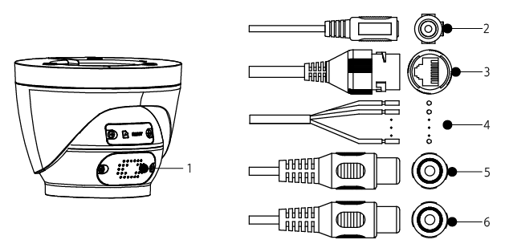
For more information about structure components, see Table 1-1.
Table 1-1 structure components
No. | Port name | Description
1 | Speaker | Outputs audio.
2 | Power input | Inputs 12V DC power. Be sure to supply power as instructed in the manual.  Device abnormity or damage could occur if power is not supplied correctly.
3 | Ethernet | ● Connects to network with network cable.  ● Provides power to the device with PoE.  PoE is available on select model.
4 | Alarm I/O | Includes alarm signal input and output ports. For detailed information, see Table 1-2.
5 | Audio input | Connects to sound pickup to receive audio signal.
6 | Audio output | Connects to speaker to output audio signal.
For more information about I/O port, see Table 1-2.
Table 1-2 Alarm information
Port | Port Name | Description
Alarm I/O | ALARM_OUT | Outputs alarm signal to alarm device.  When connecting to alarm device, only the ALARM_OUT port and ALARM_OUT_GND port with the same number can be used together.
Alarm I/O | ALARM_OUT_GND
Alarm I/O | ALARM_IN | Receives the switch signal of external alarm source.  Connect different alarm input devices to the same ALARM_IN_GND port.
Alarm I/O | ALARM_IN_GND

1.2 Connecting Alarm Input/Output
The camera can connect to external alarm input/output device through digital input/output.
Alarm input/output is available on select models.
Step 1 Connect alarm input device to the alarm input end of the I/O port. See Figure 1-2.
Device collects different states of alarm input port when the input signal is idling and being grounded.
● Device collects logic "1" when input signal is connected to +3V to +5V or idling.
● Device collects logic "0" when input signal is grounded.
Figure 1-2 Alarm input
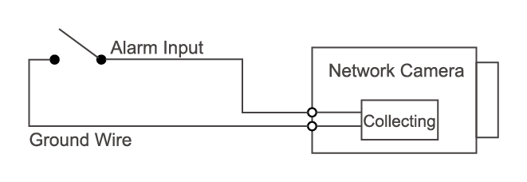
Step 2 Connect alarm output device to the alarm output end of the I/O port. The alarm output is open-drain output, which works in the following modes.
● Mode A: Level application. Alarm outputs high and low level, and the alarm outlet is OD, which requires external pull-up resistance (10K Ohm typical) to work. The maximum external pull-up level is 12V, maximum port current is 300mA and the default output signal is high-level (external pull-up voltage). The default output signal switches to low- level when there is alarm output (As long as the operating current is below 300mA, the output low-level voltage is lower than 0.8V).
● Mode B: Switch application. Alarm output is used to drive external circuit, the maximum voltage is 12V and the maximum current is 300mA. If the voltage is higher than 12V, please use an additional electric relay.
Figure 1-3 Mode A
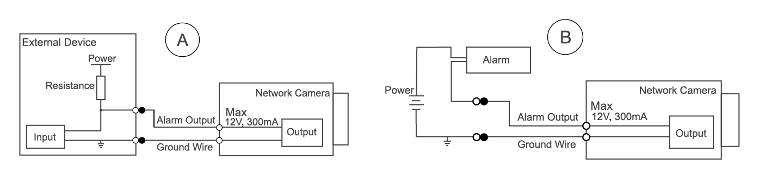
Step 3 Log in to web interface, and configure alarm input and alarm output in alarm setting.
● The alarm input on the web interface is corresponding to the alarm input end of the I/O port. There will be high level and low level alarm signal generated by the alarm input device when alarm occurs, set the input mode to "NO" (default) if the alarm input signal is logic "0" and to "NC" if the alarm input signal is logic "1".
● The alarm output on the web interface is corresponding to the alarm output end of the device, which is also alarm output end of the I/O port.

2 Network Configuration
Device initialization and IP setting can be finished with the "ConfigTool" or on web interface. For more information, see the Web Operation Manual.
● Device initialization is available on select models, and it is required at first-time use and after device is being reset.
● Device initialization is available only when the camera (whose IP address is 192.168.1.108 by default) and the PC stays in the same network segment.
● Plan usable network segment properly to connect the device to the network.
● The following figures and interfaces are for reference only, and the actual product shall prevail.

2.1 Initializing Device
Step 1 Double-click "ConfigTool.exe" to open the tool.
Step 2 Click .
The Modify IP interface is displayed.
Figure 2-1 Modify IP
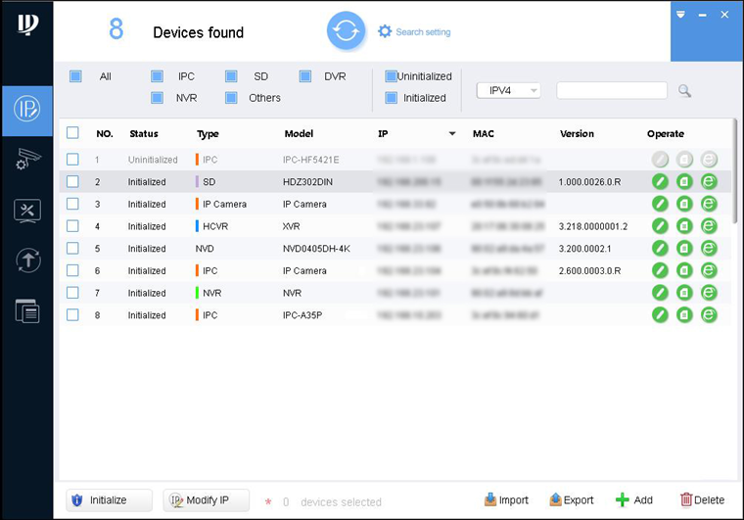
Step 3 Click Search setting.
The Setting interface is displayed.
Step 4 Enter the start IP address and end IP address of the network segment in which you want to search devices, and then click OK.
All the devices found in the network segment are listed.
Step 5 Select one or several devices in uninitialized status, and then click Initialize.
The Device initialization interface is displayed.
Step 6 Select the devices that need initialization, and then click Initialize.
The password setting interface is displayed.
Figure 2-2 Password setting
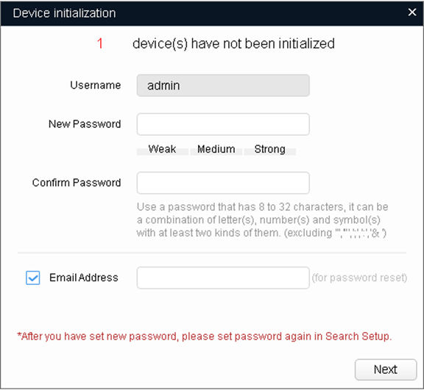
Step 7 Set and confirm the password of the devices, then enter a valid email address, and then click Next.
The final setting interface is displayed.
Password can be modified or reset in System Settings.
Step 8 Select the options according to your needs, and then click OK.
The Initialization interface is displayed after initialization is completed. Click the success icon () or the failure icon () for the details.
Step 9 Click Finish.
The device status on the Modify IP interface (Figure 2-1) turns to Initialized.

2.2 Modifying Device IP Address
● You can modify IP address of one or multiple devices at one time. This section is based on modifying IP addresses in batches.
● Modifying IP addresses in batches is available only when the corresponding devices have the same login password.
Step 1 Do Step1 to Step4 in "2.1 Initializing Device" to search devices in your network segment.
After clicking Search setting, enter the username and password, and make sure that they are the same as what you set during initialization; otherwise there will be wrong password notice.
Step 2 Select the devices whose IP addresses need to be modified, and then click Modify IP.
The Modify IP Address interface is displayed.
Figure 2-3 Modify IP address
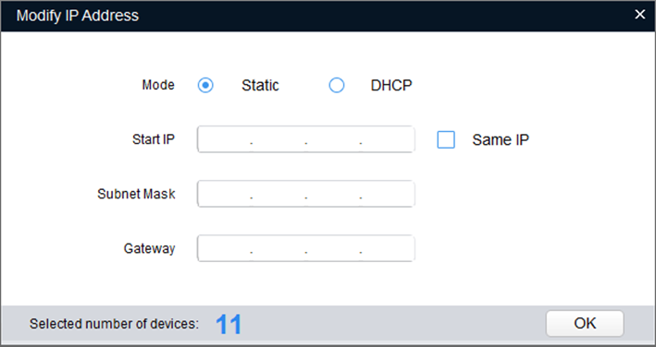
Step 3 Select Static mode, and then enter start IP, subnet mask, and gateway.
● IP addresses of multiple devices will be set to the same if you select the Same IP check box.
● If DHCP server is available in the network, devices will automatically obtain IP addresses from DHCP server when you select DHCP.
Step 4 Click OK.

2.3 Logging in to Web Interface
Step 1 Open IE browser, enter the IP address of the device in the address bar, and then press Enter key.
If the setup wizard is displayed, finish the settings as instructed.
Step 2 Enter the username and password in the login box, and then click Login.
Step 3 For the first-time login, click Click Here to Download Plugin, and then install the plugin as instructed.
The main interface is displayed when the installation is finished.
Figure 2-4 Main interface
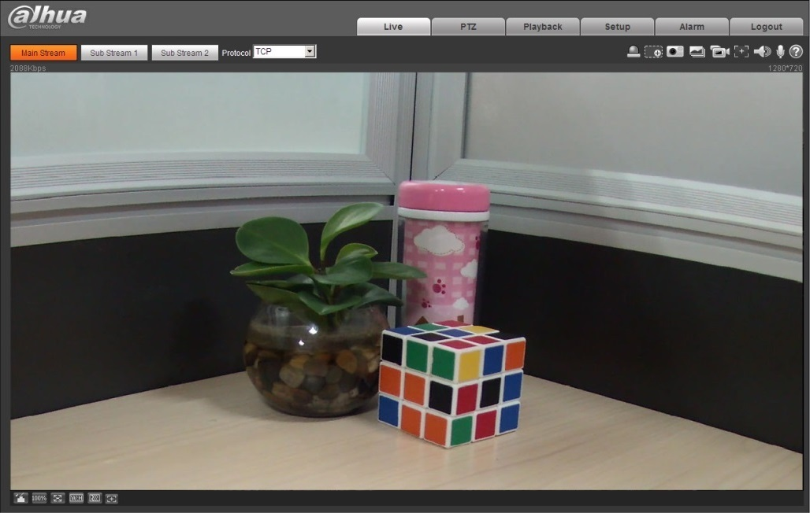

3 Installation

3.1 Packing List
● The tool required for the installation such as electric drill is not provided in the package.
● The operation manual and related tool information are contained in the disk or the QR code, and the actual package shall prevail.
Figure 3-1 Packing list
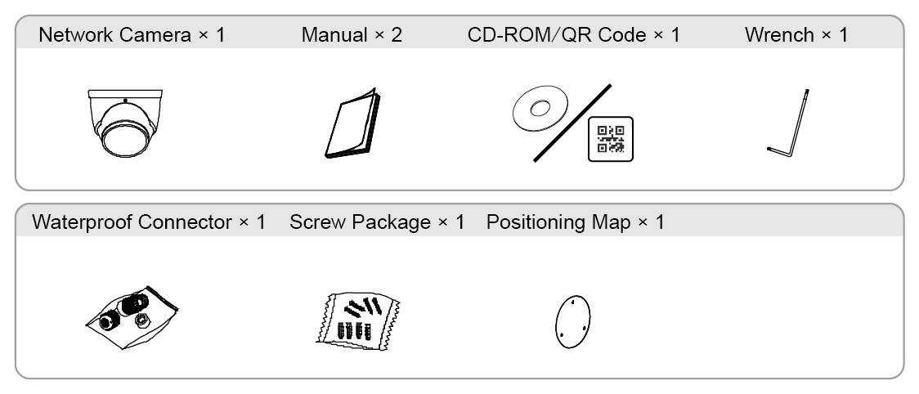

3.2 Dimensions
Following figures are for reference only, and the actual product shall prevail.
Figure 3-2 Dimensions (Unit: mm [inch])
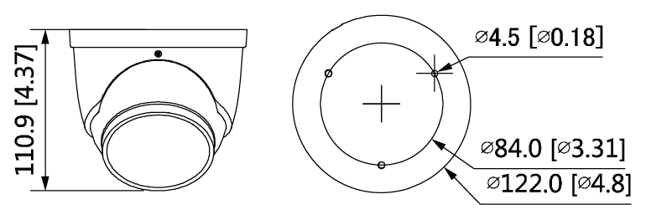

3.3 Installing Camera

3.3.1 Installation Method

Figure 3-3 Installation method
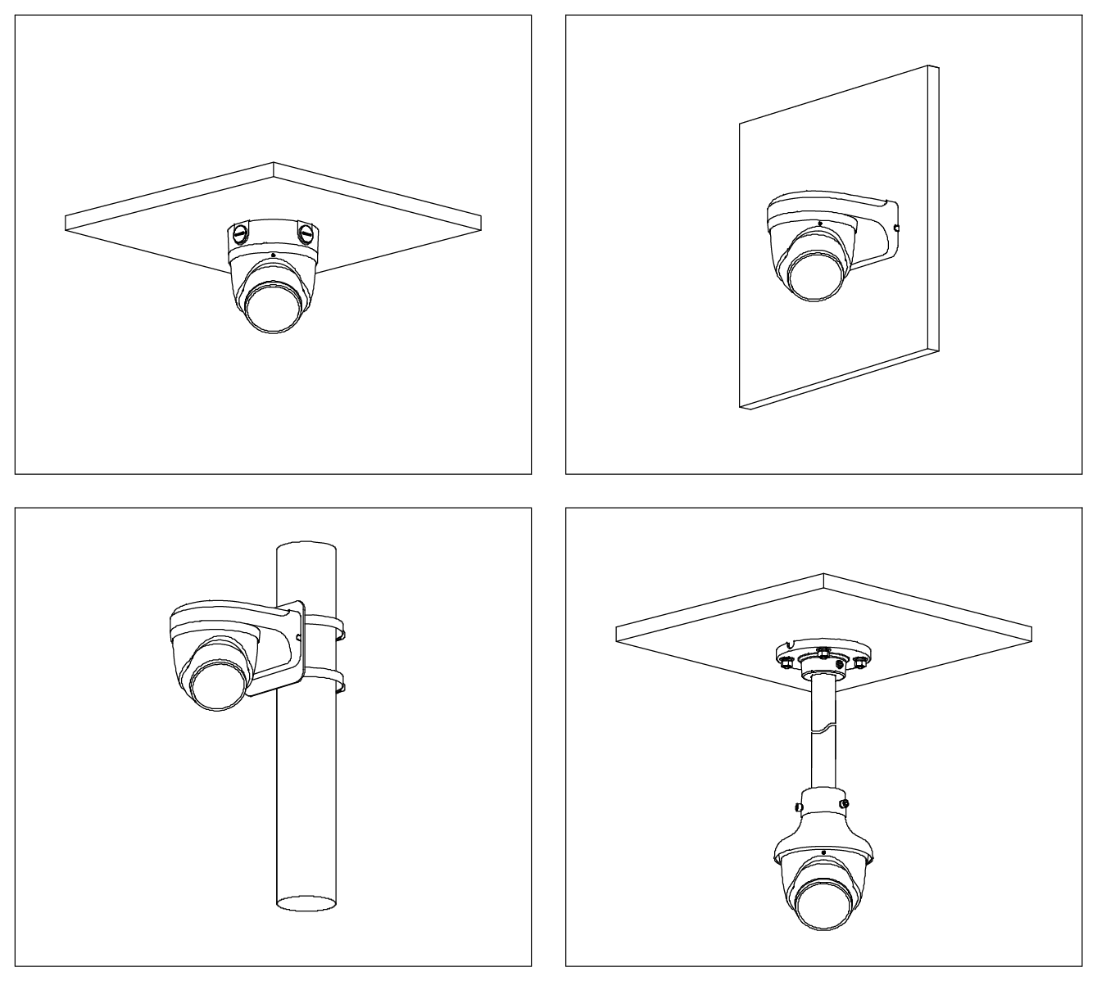

3.3.2 Installing SD Card (Optional)
● SD card slot is available on select models.
● Disconnect the power before installing or removing the SD card.

Figure 3-4 Installing SD card
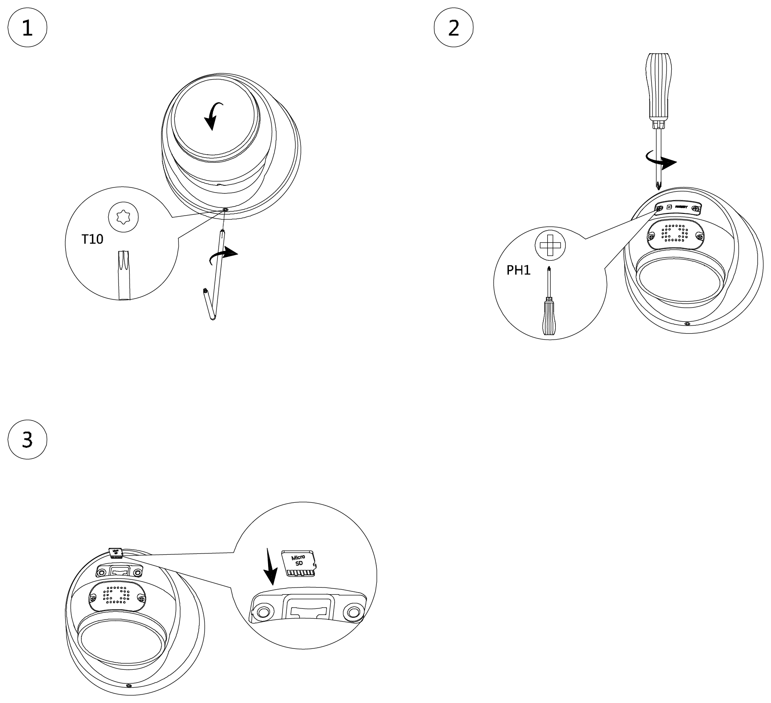
Press the reset button for 10 seconds to reset the device.

3.3.3 Attaching Camera
Make sure that the mounting surface is strong enough to hold at least three times the weight of the device and bracket.
Figure 3-5 Cable going through the side cable tray
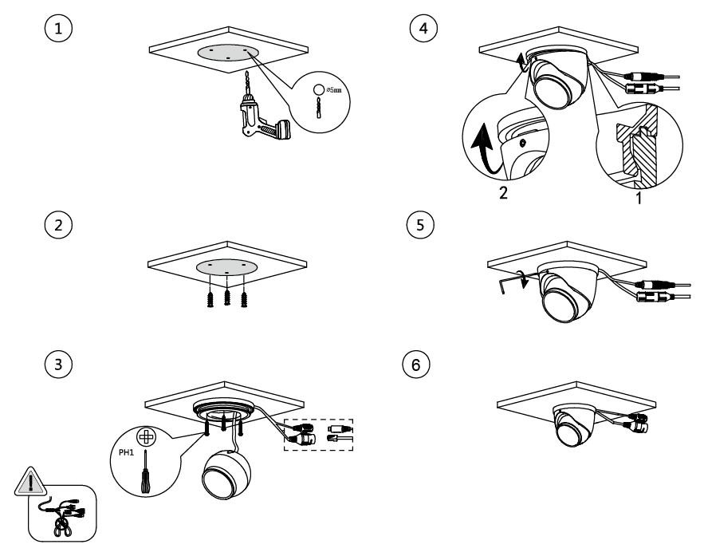

Figure 3-6 Cable going through the mounting surface
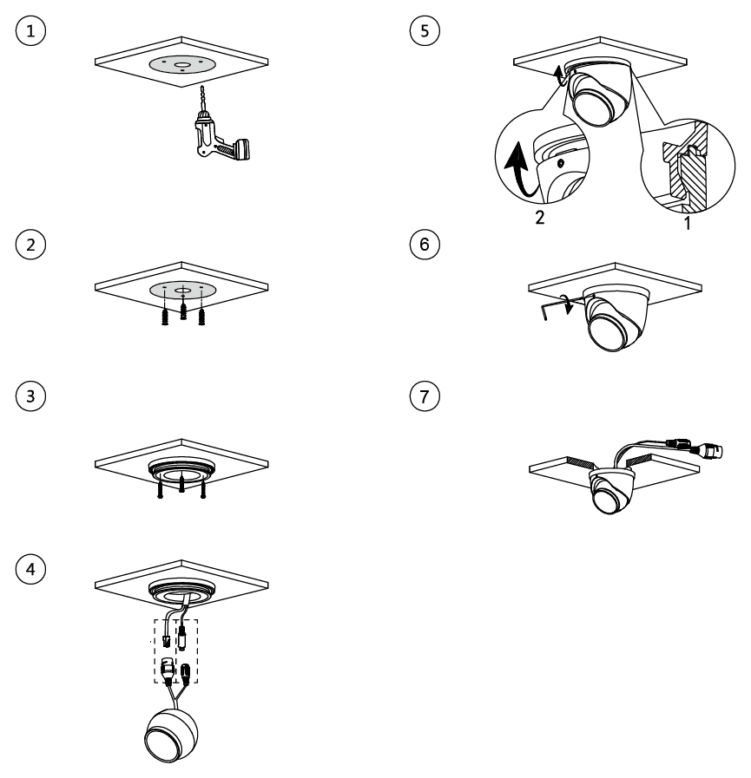

3.3.4 Installing Waterproof Connector (Optional)
This part is needed only when there is waterproof connector in the package and the device is used outdoors.

Figure 3-7 Installing waterproof connector
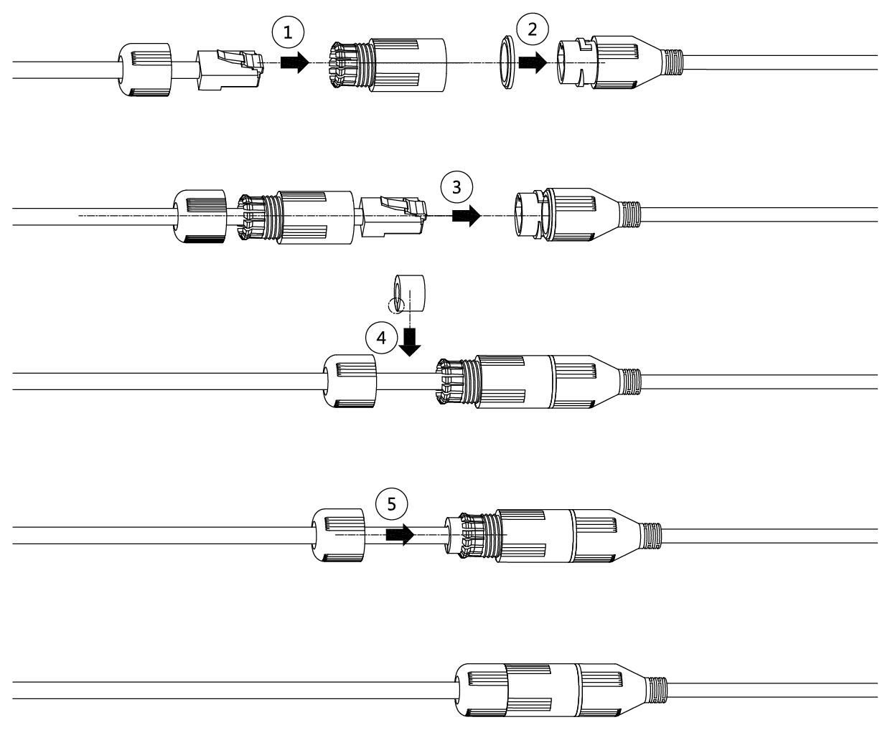

3.3.5 Adjusting Lens Angle

Figure 3-8 Adjusting lens angle
